Big Data:
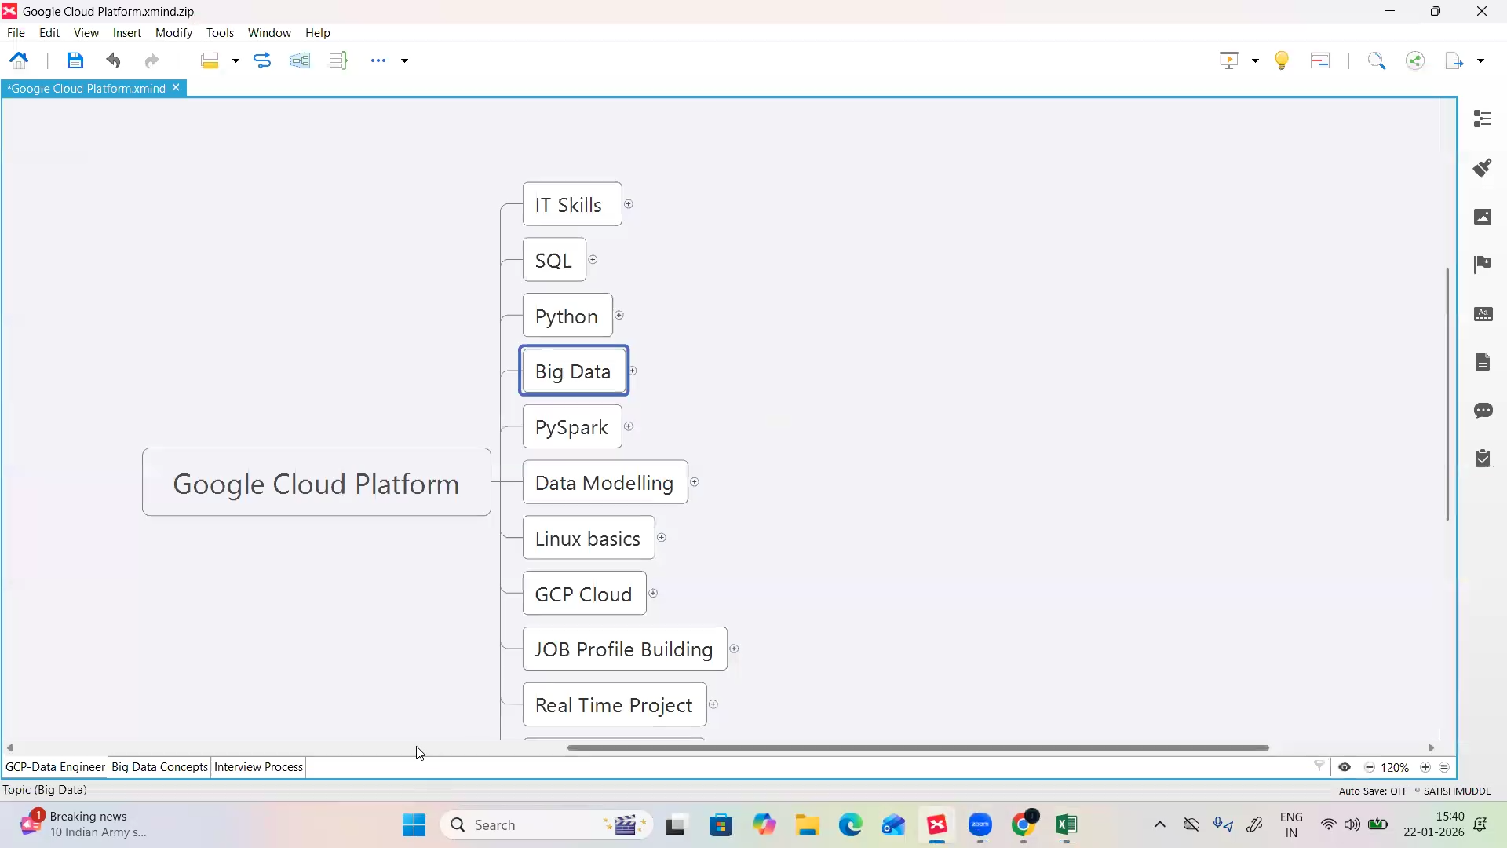
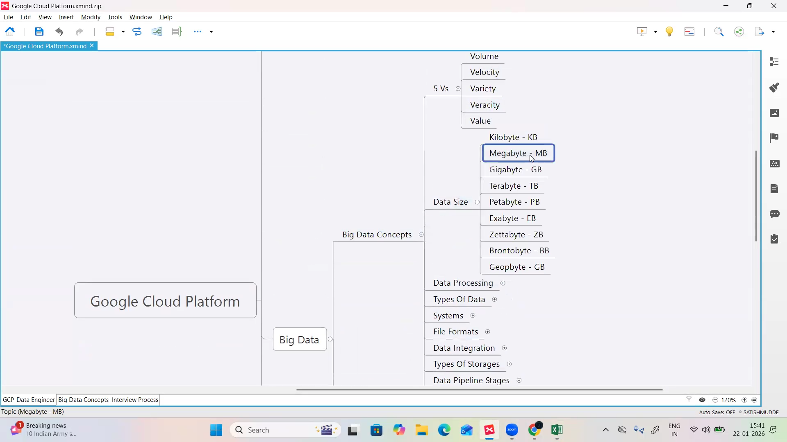
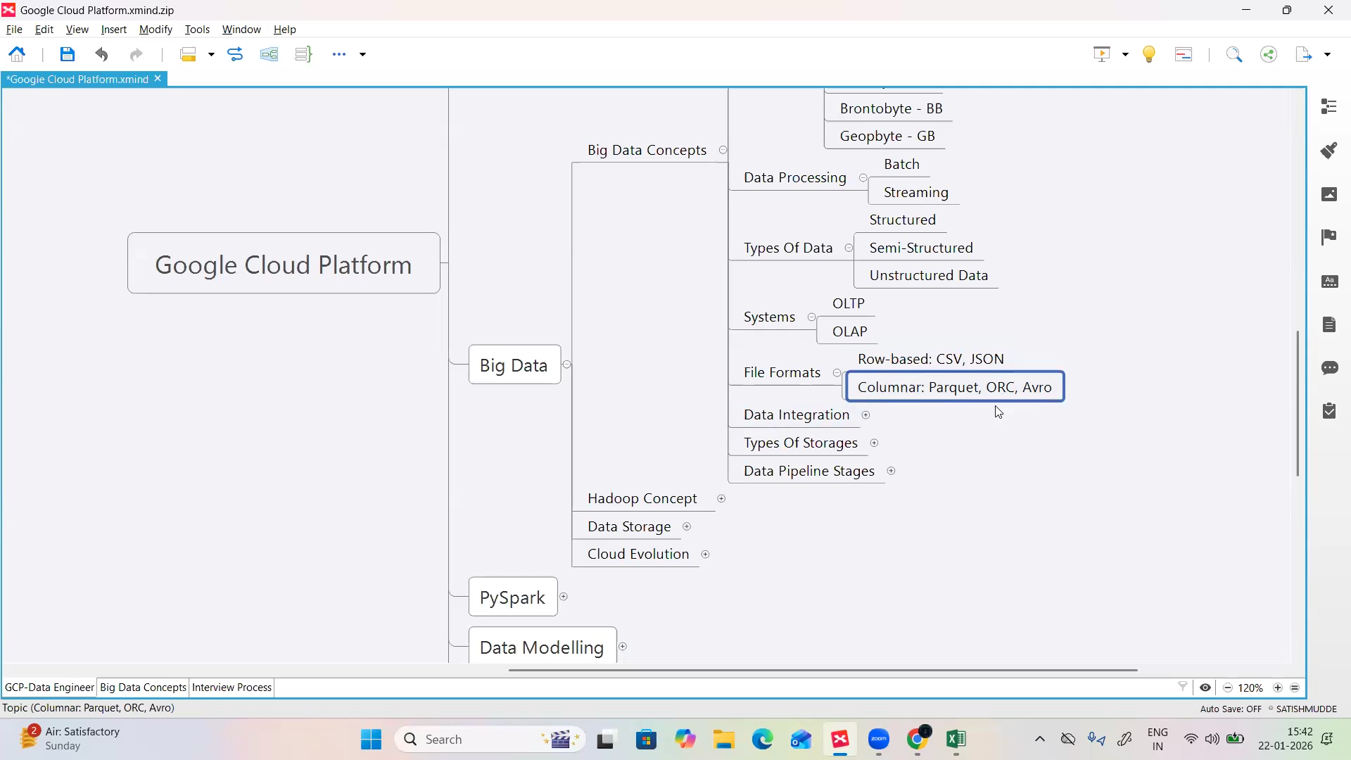
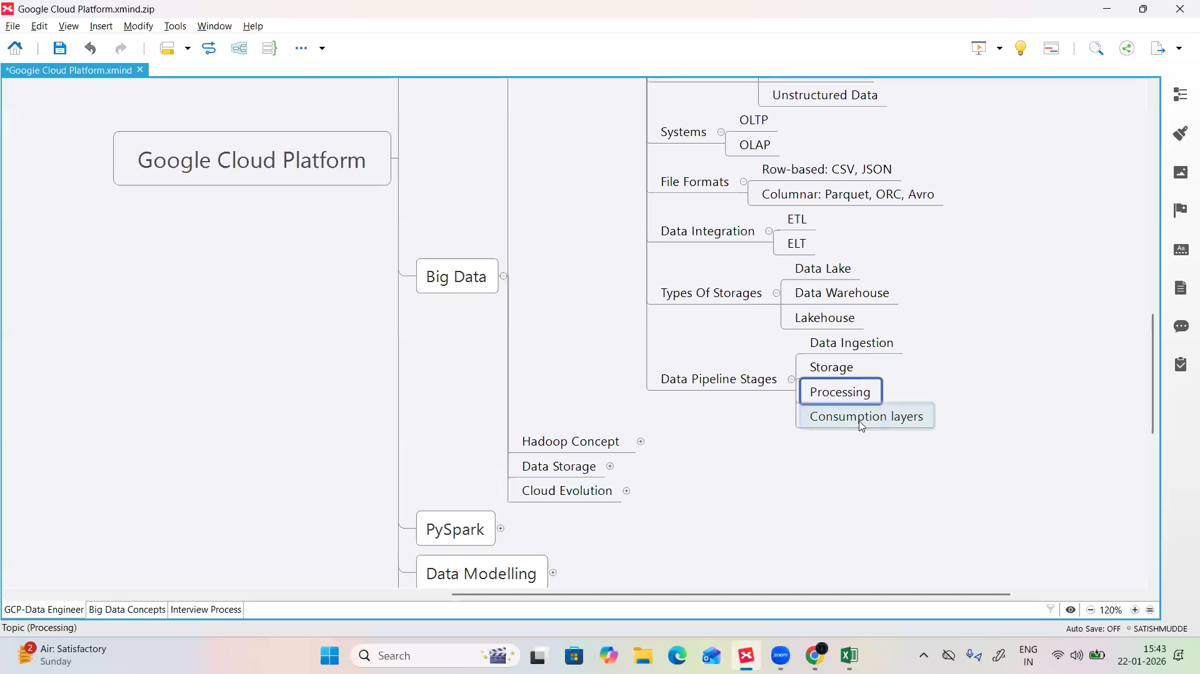

Hadoop:
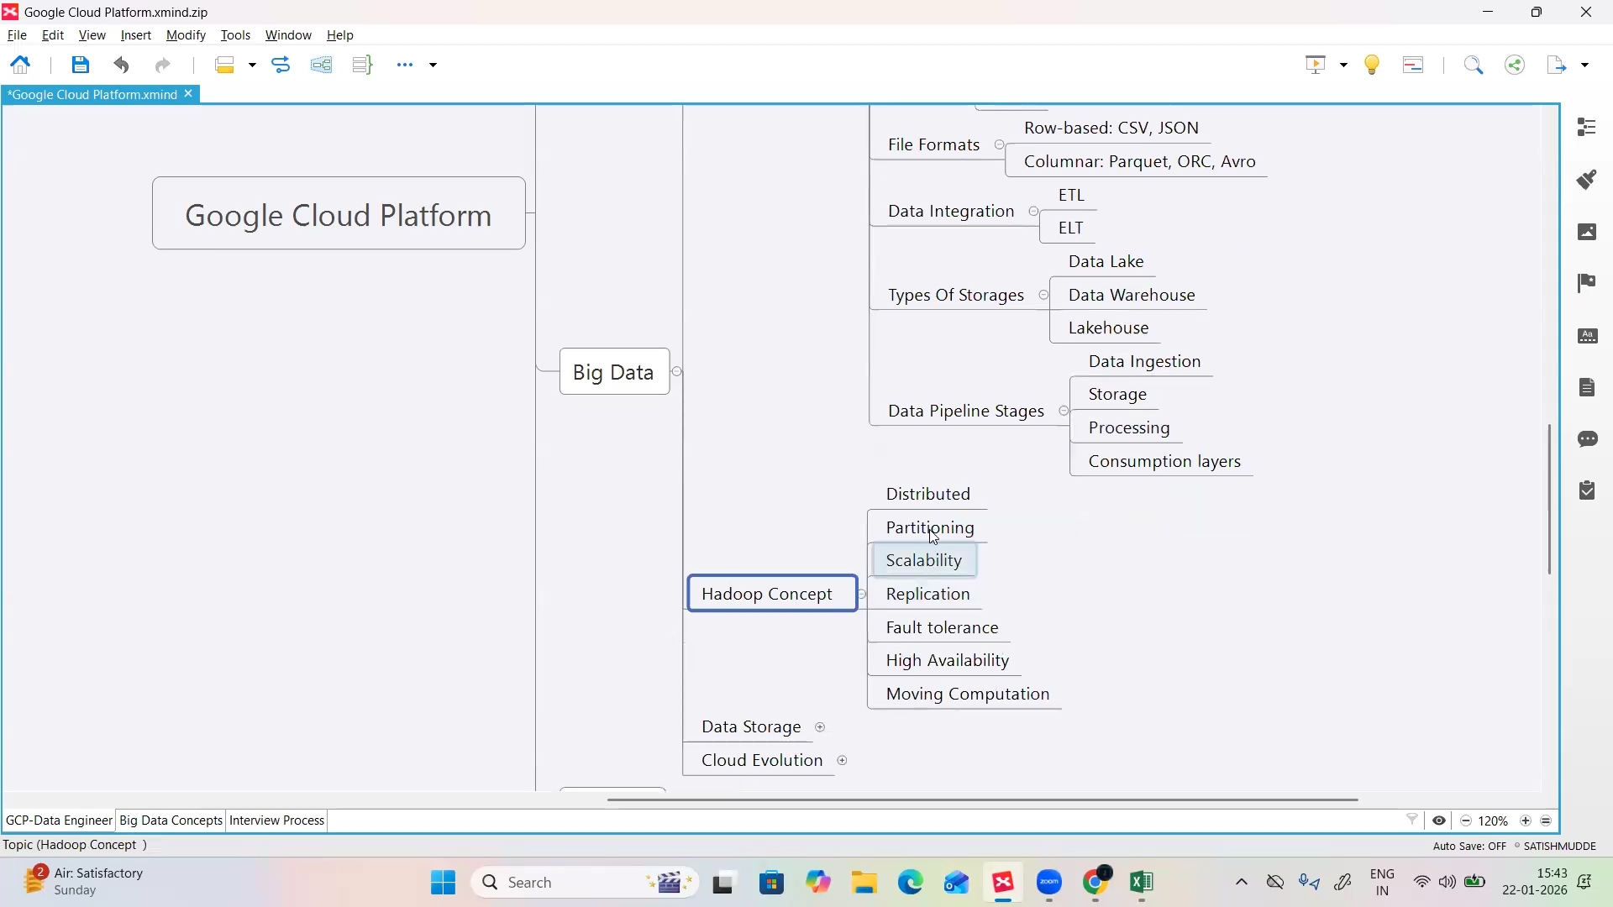
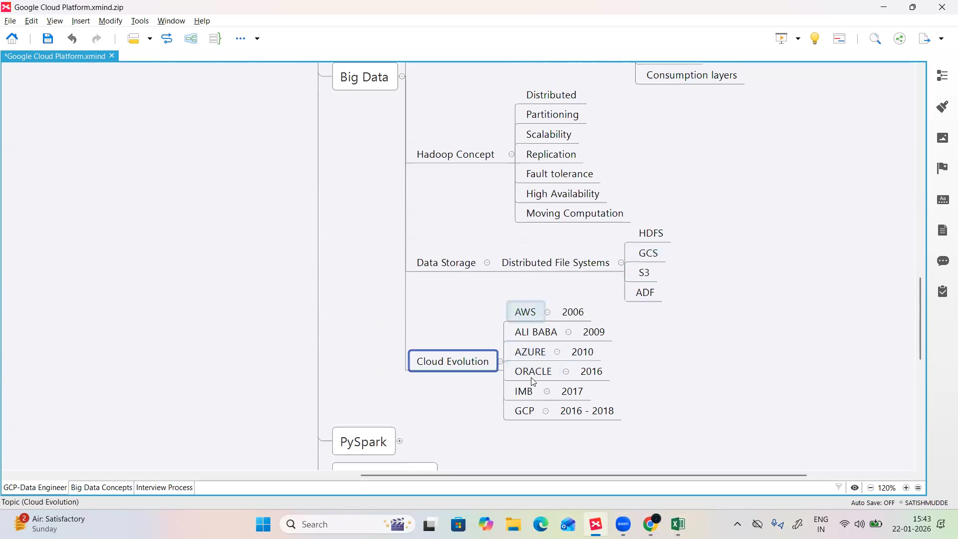
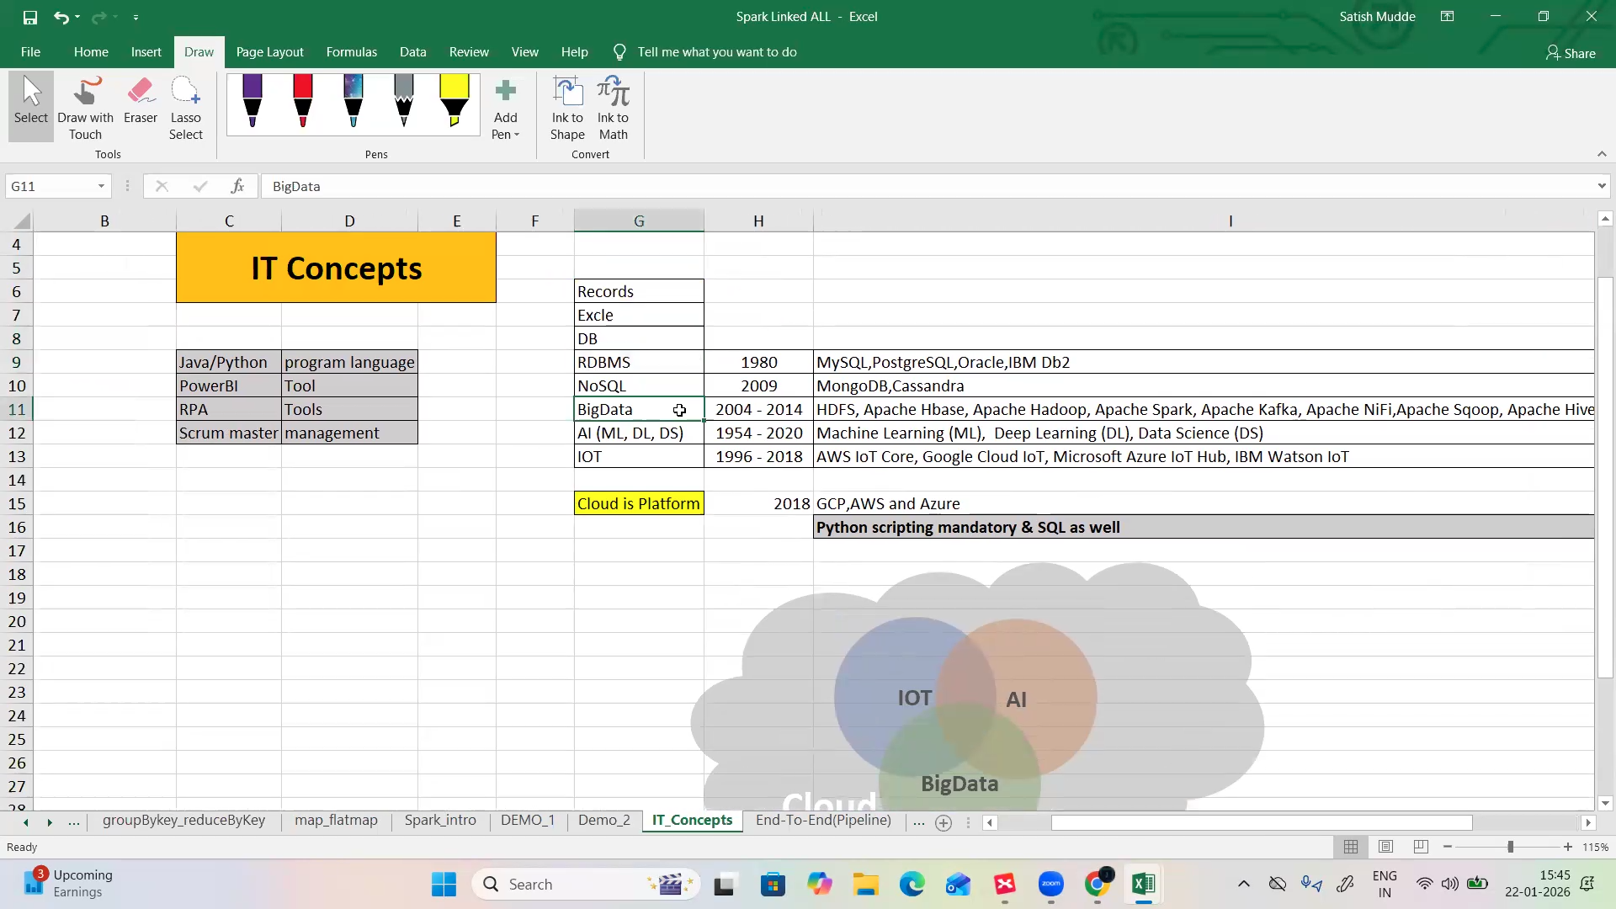

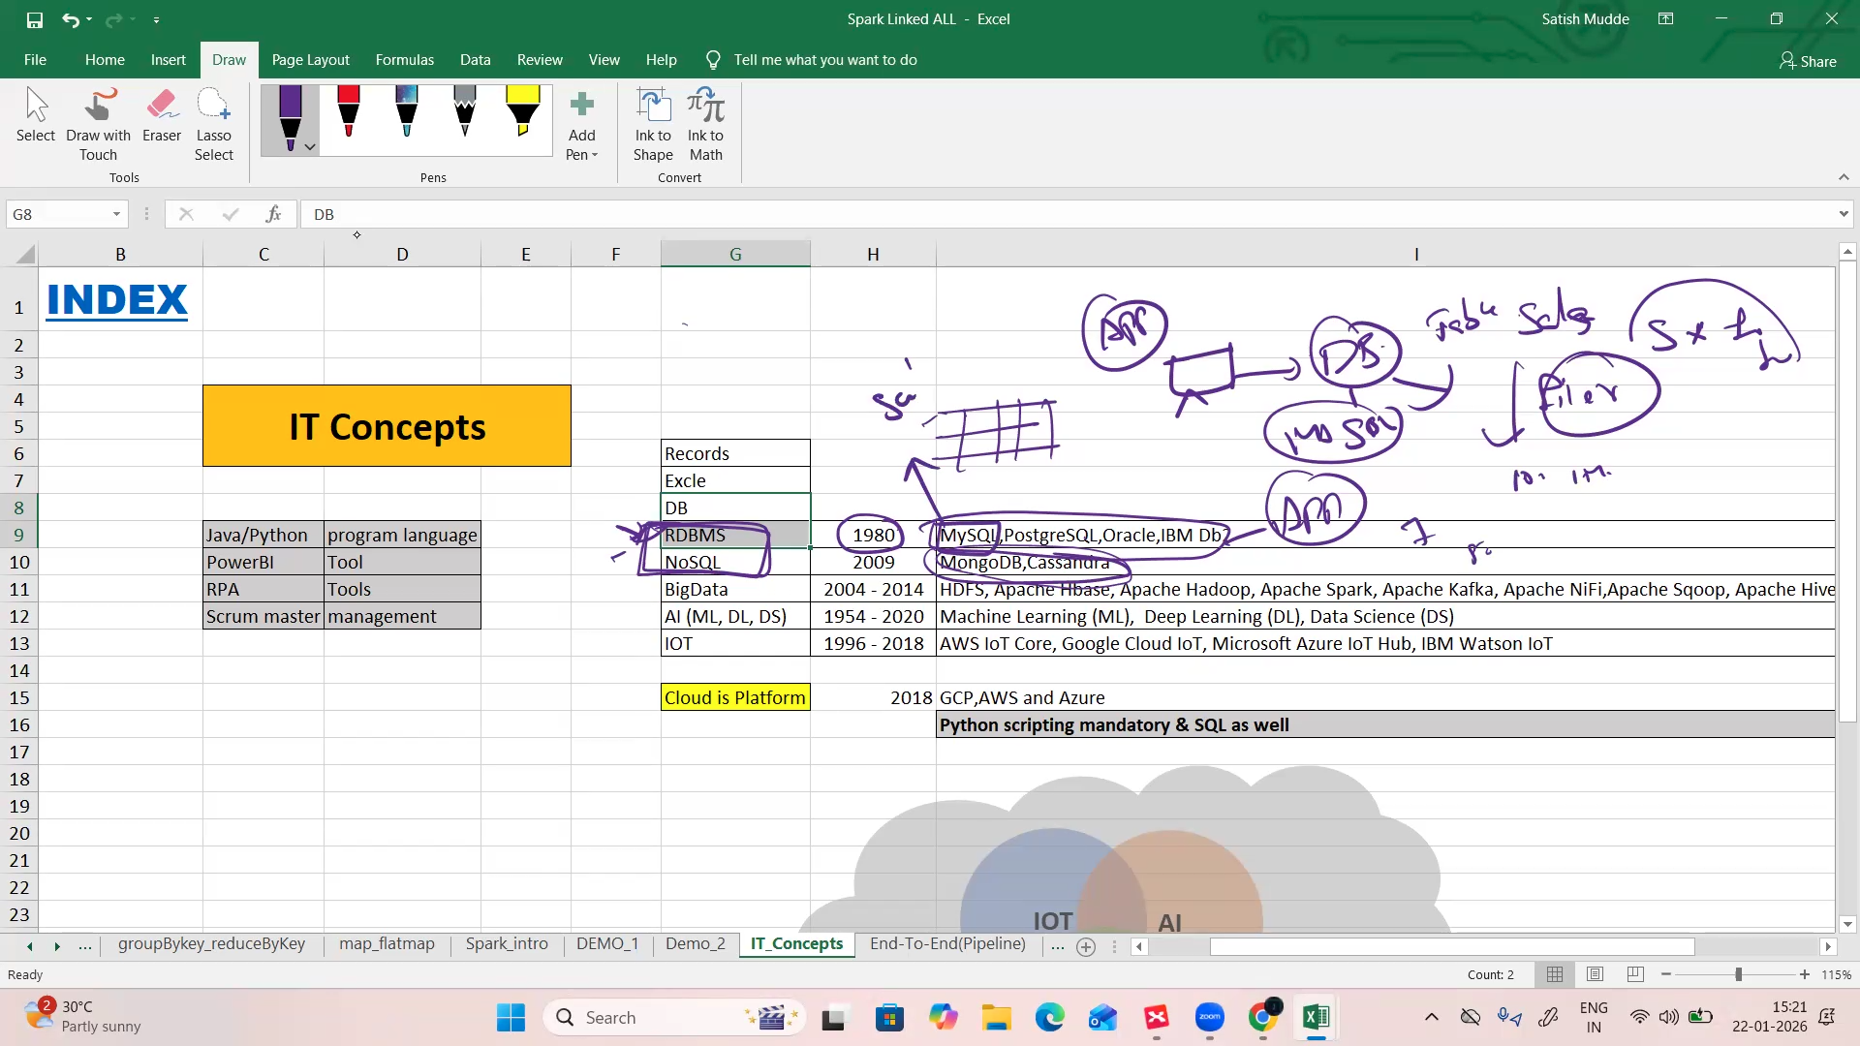
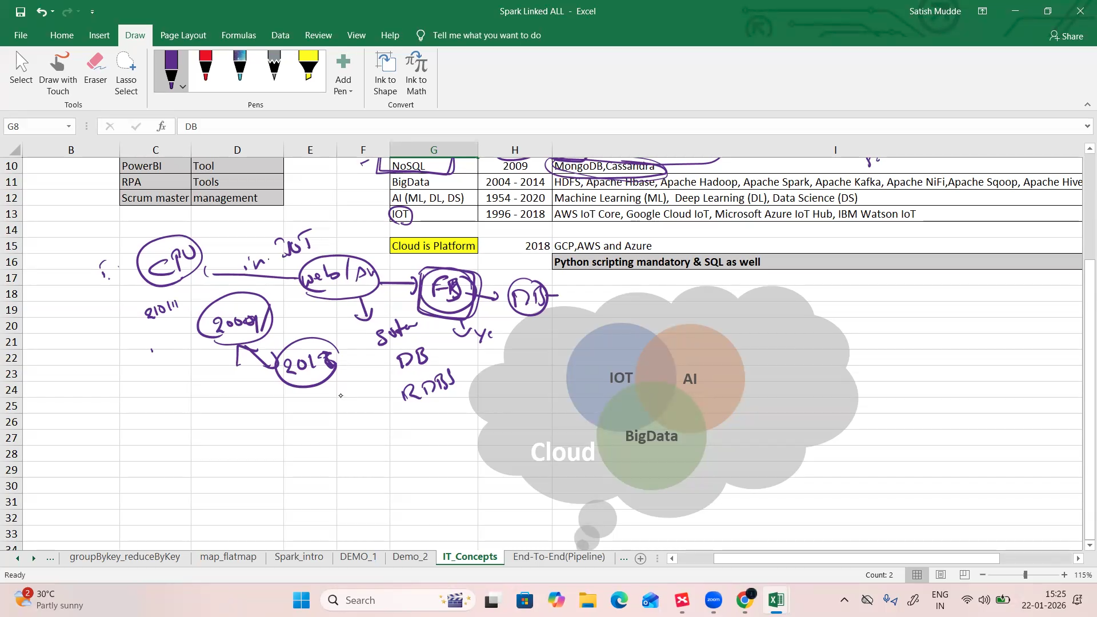
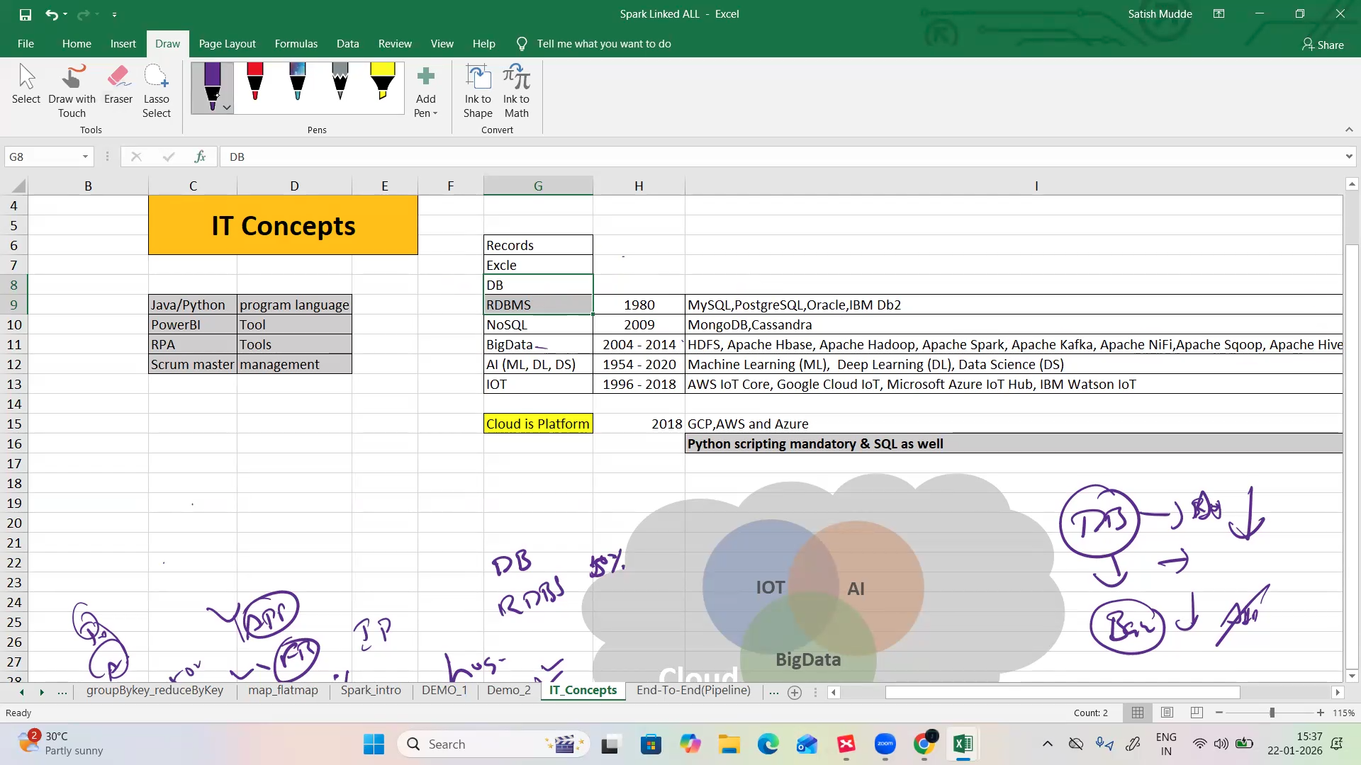

- RDBMS in Bigdata is HIVE
- HIVE is a data warehouse
- Hive is for better performance
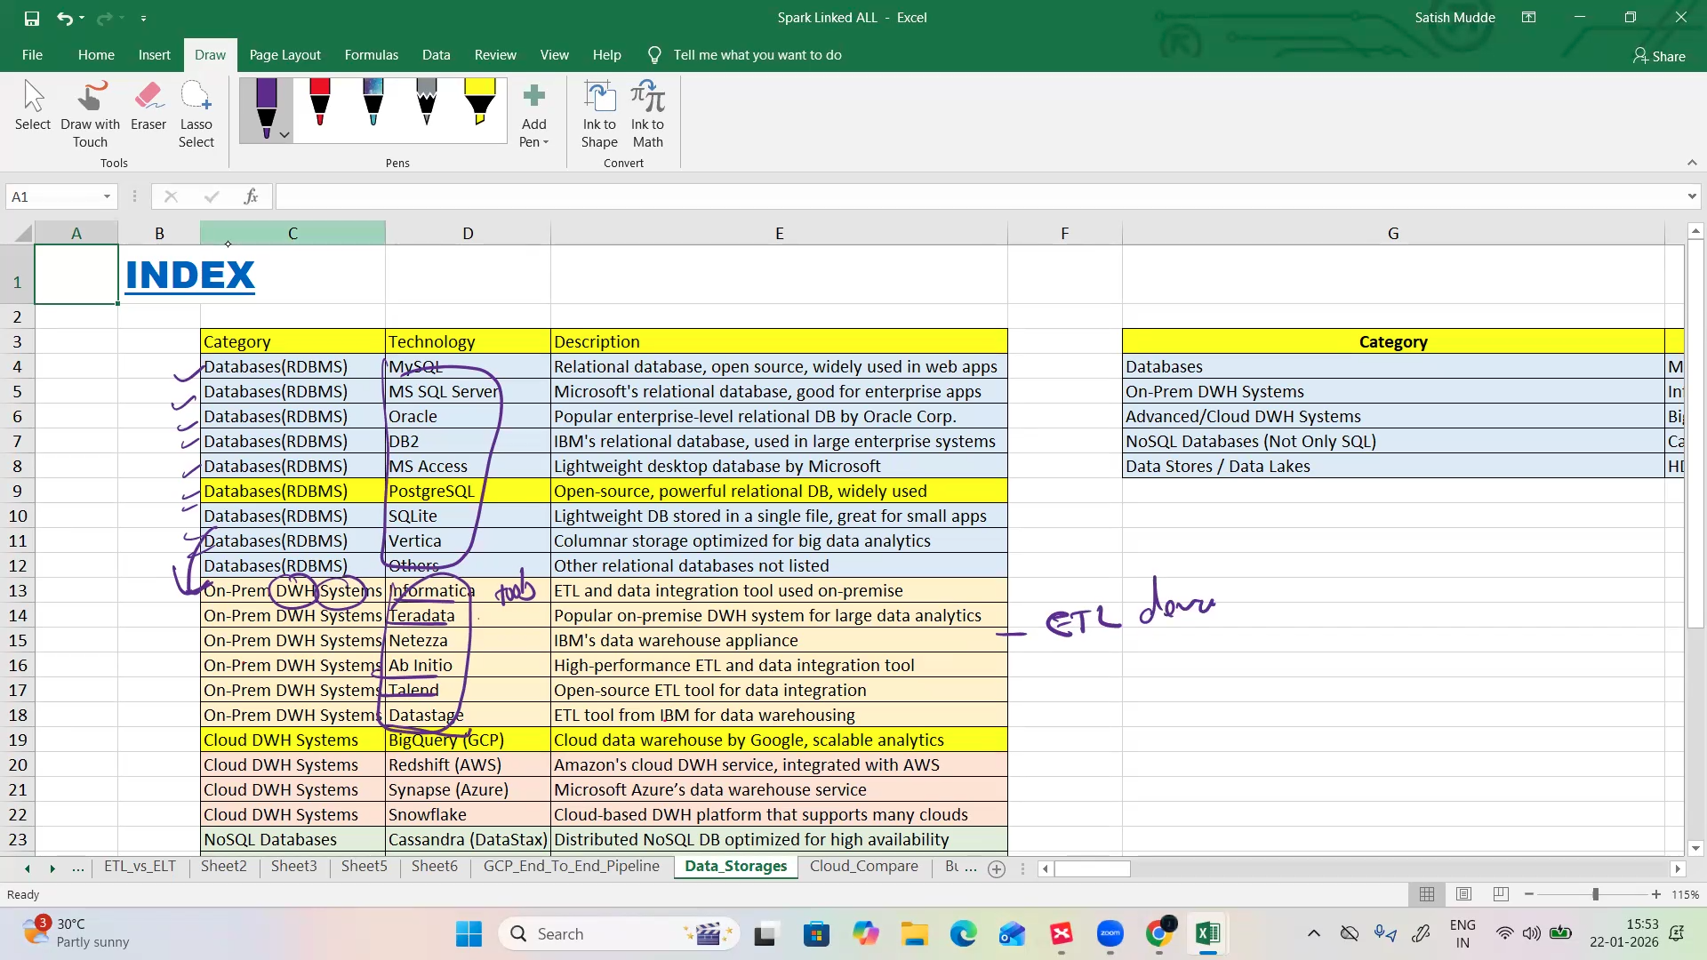

- Five V’s in bigdata:
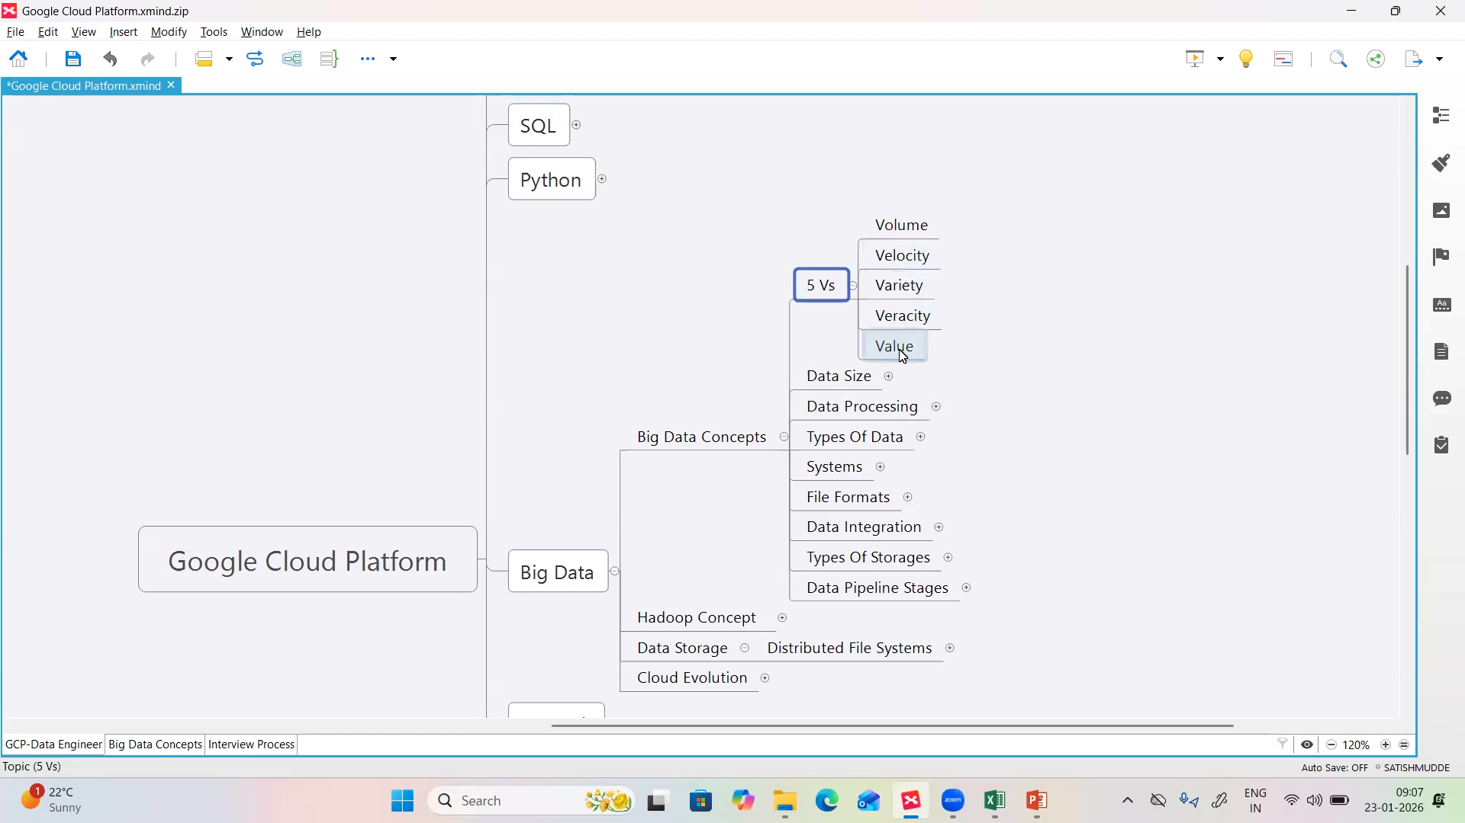
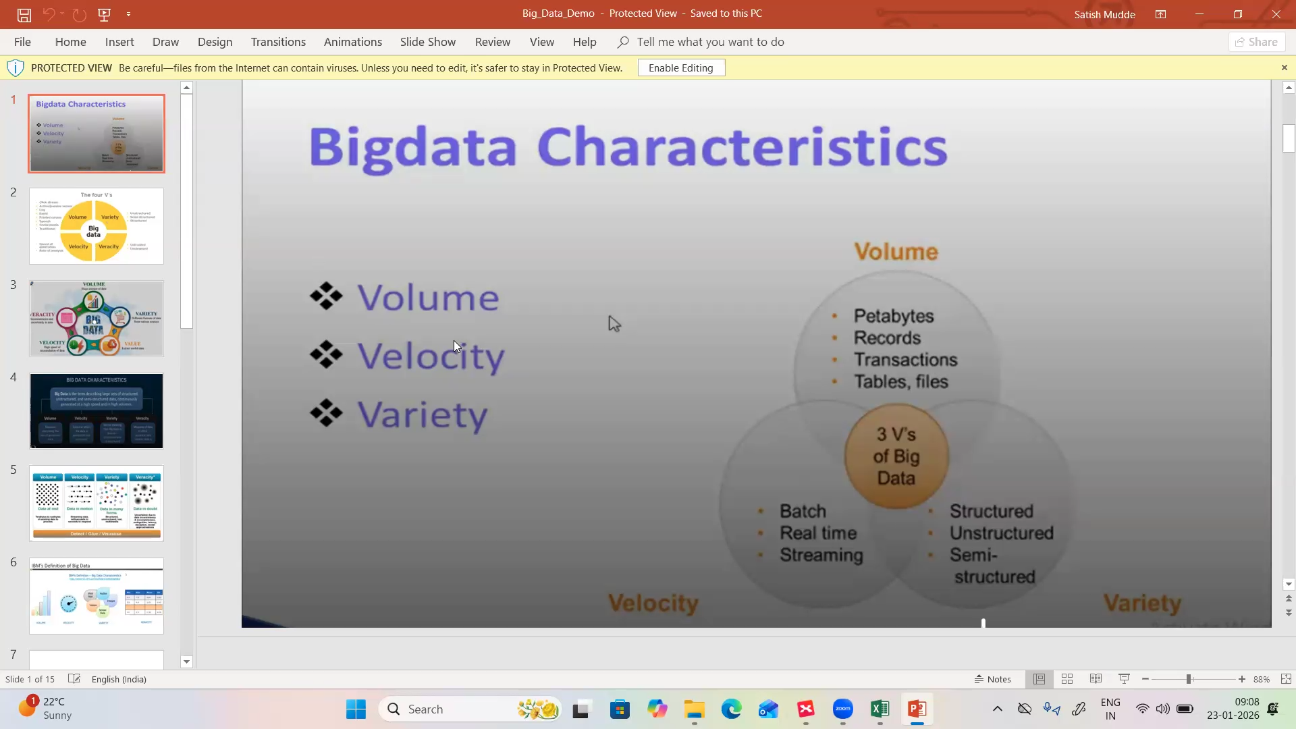
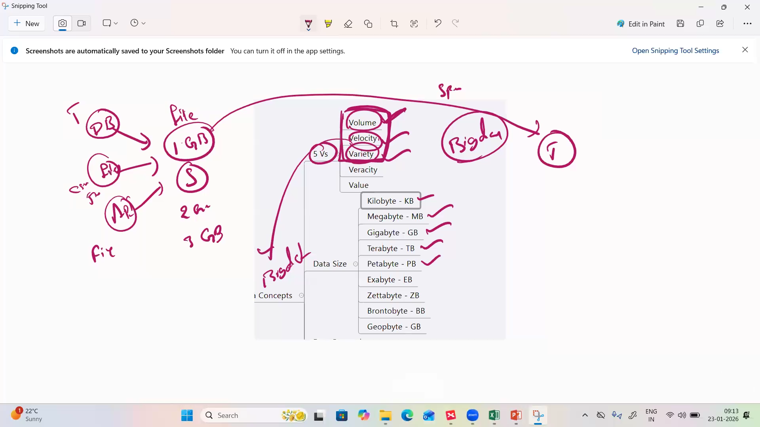
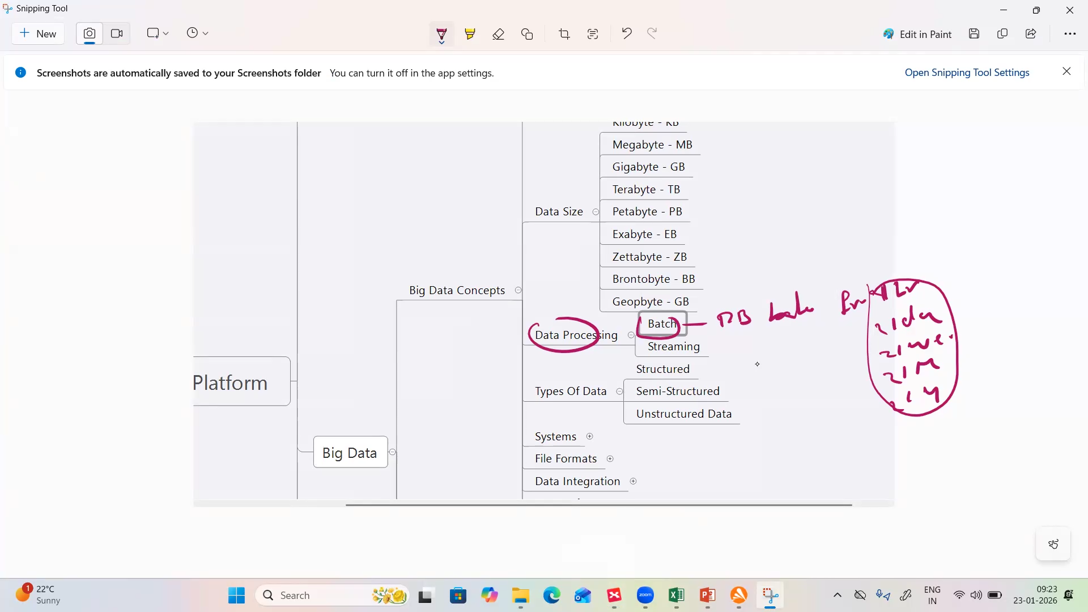
- CSV file is structured data
- JSON file in structured format but it is semi structured
- Data we get from any API is in JSON format

Veracity:
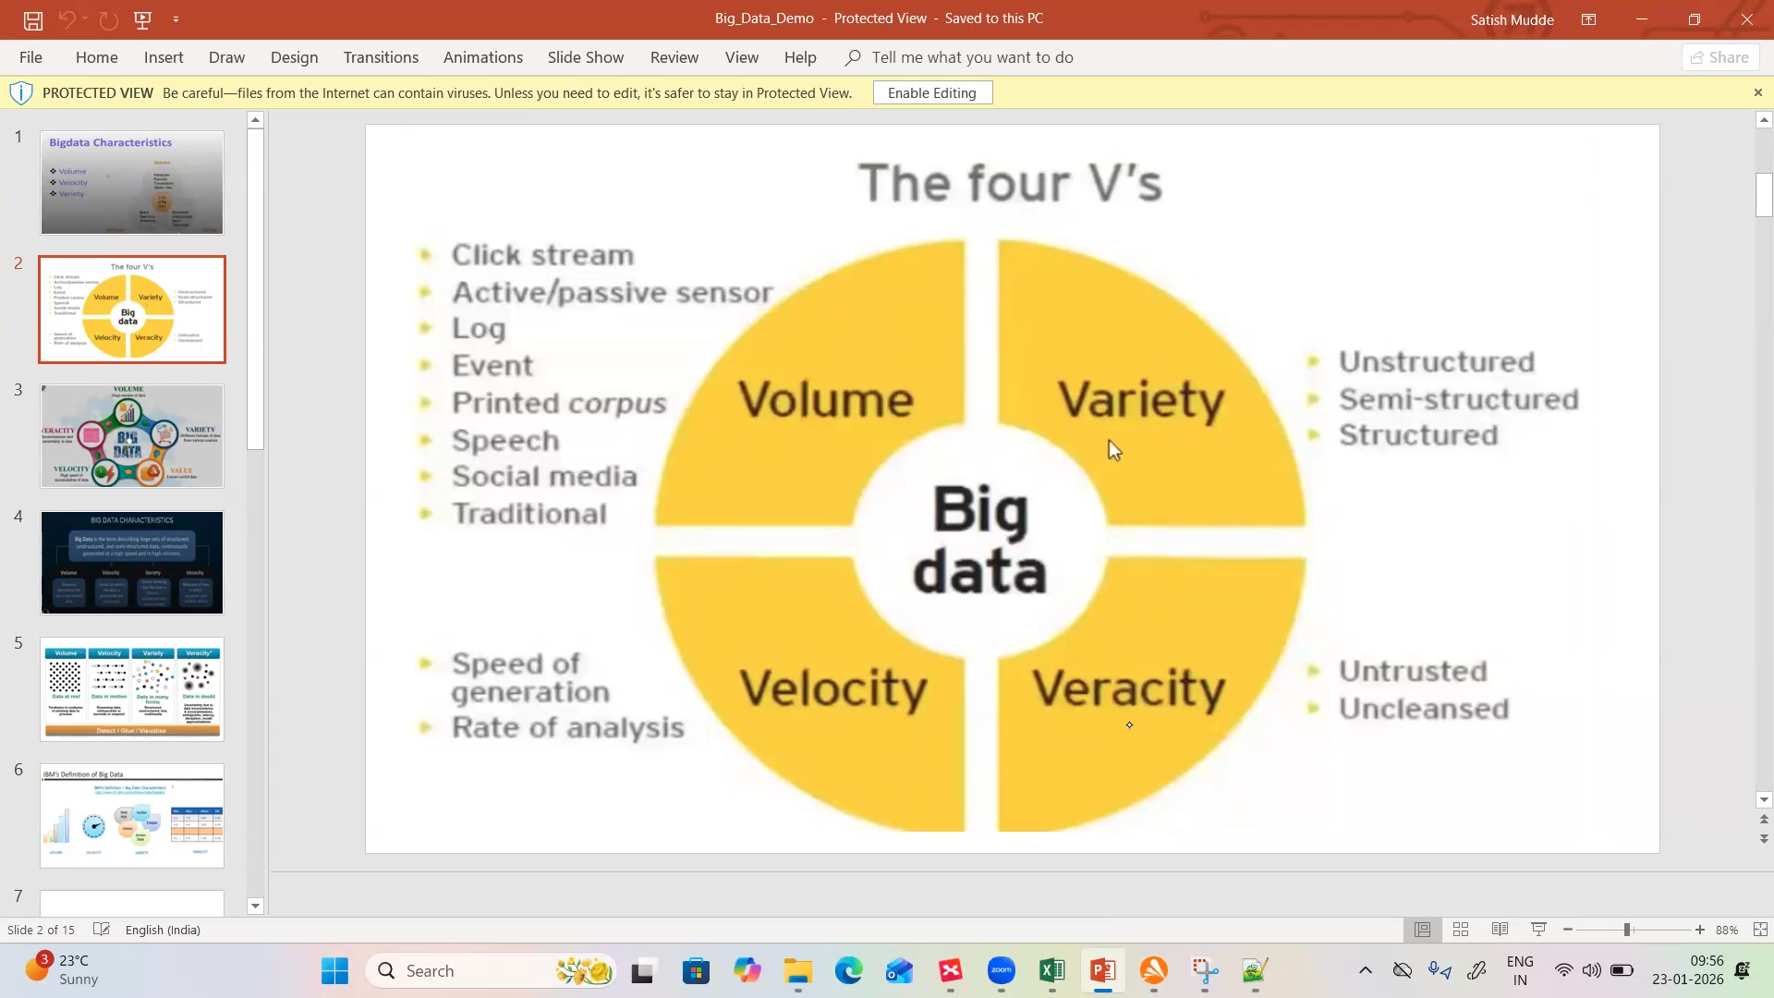
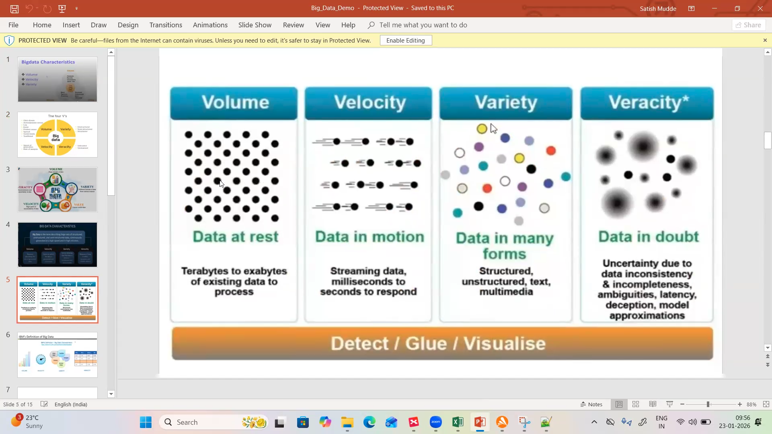
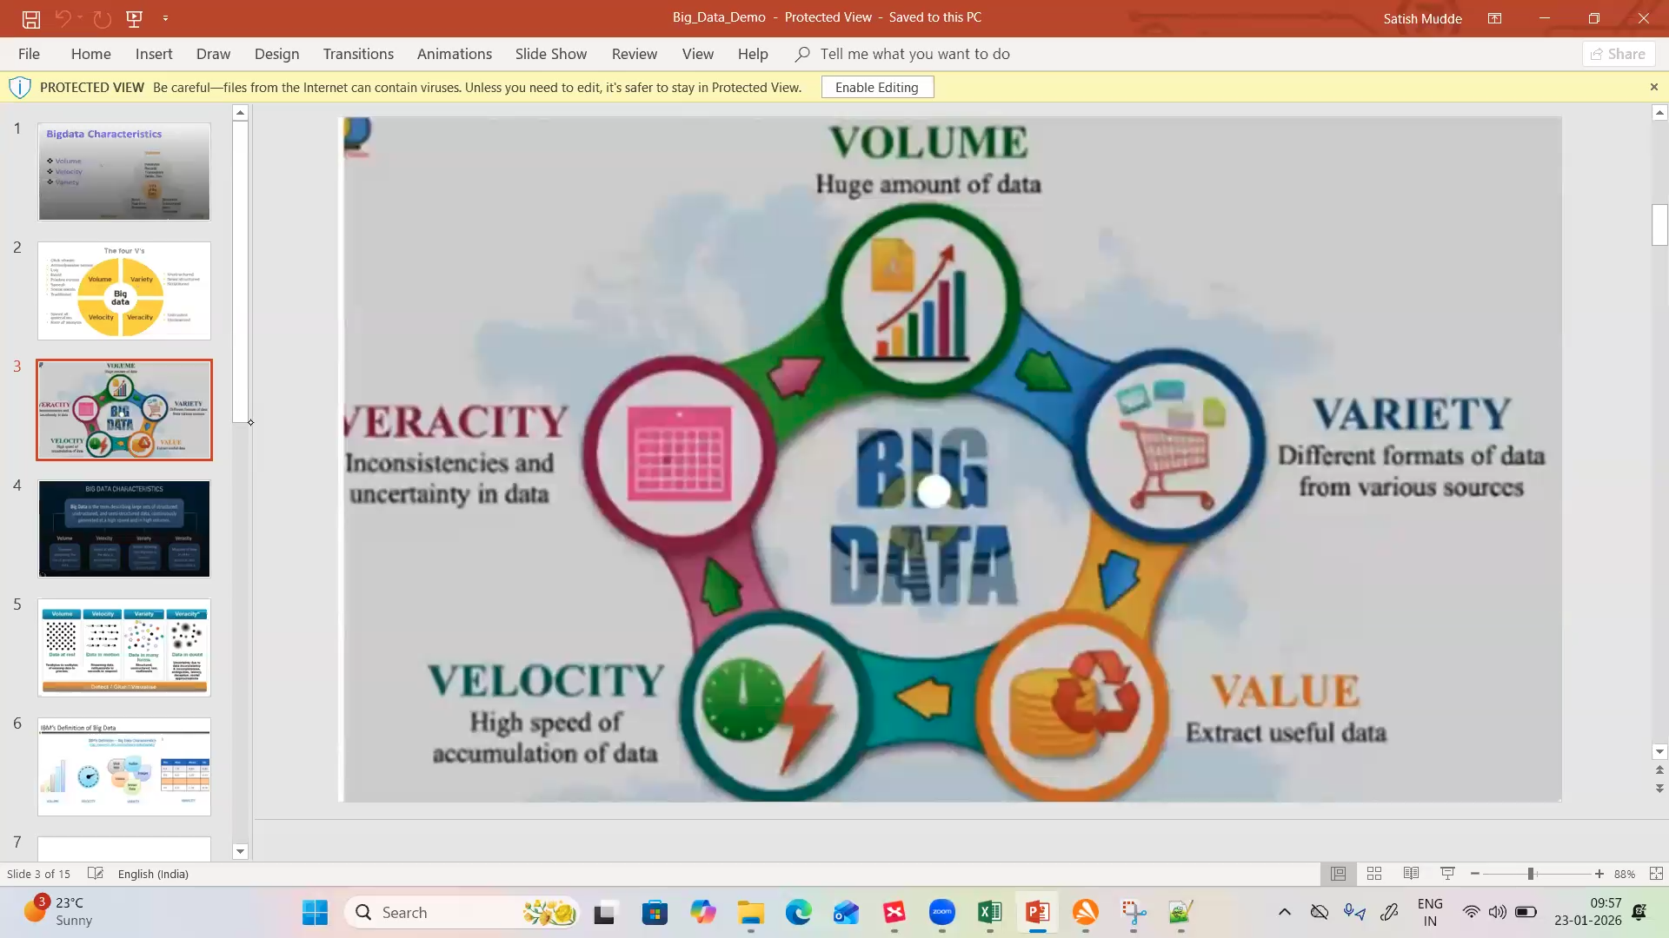

Big data characteristics:
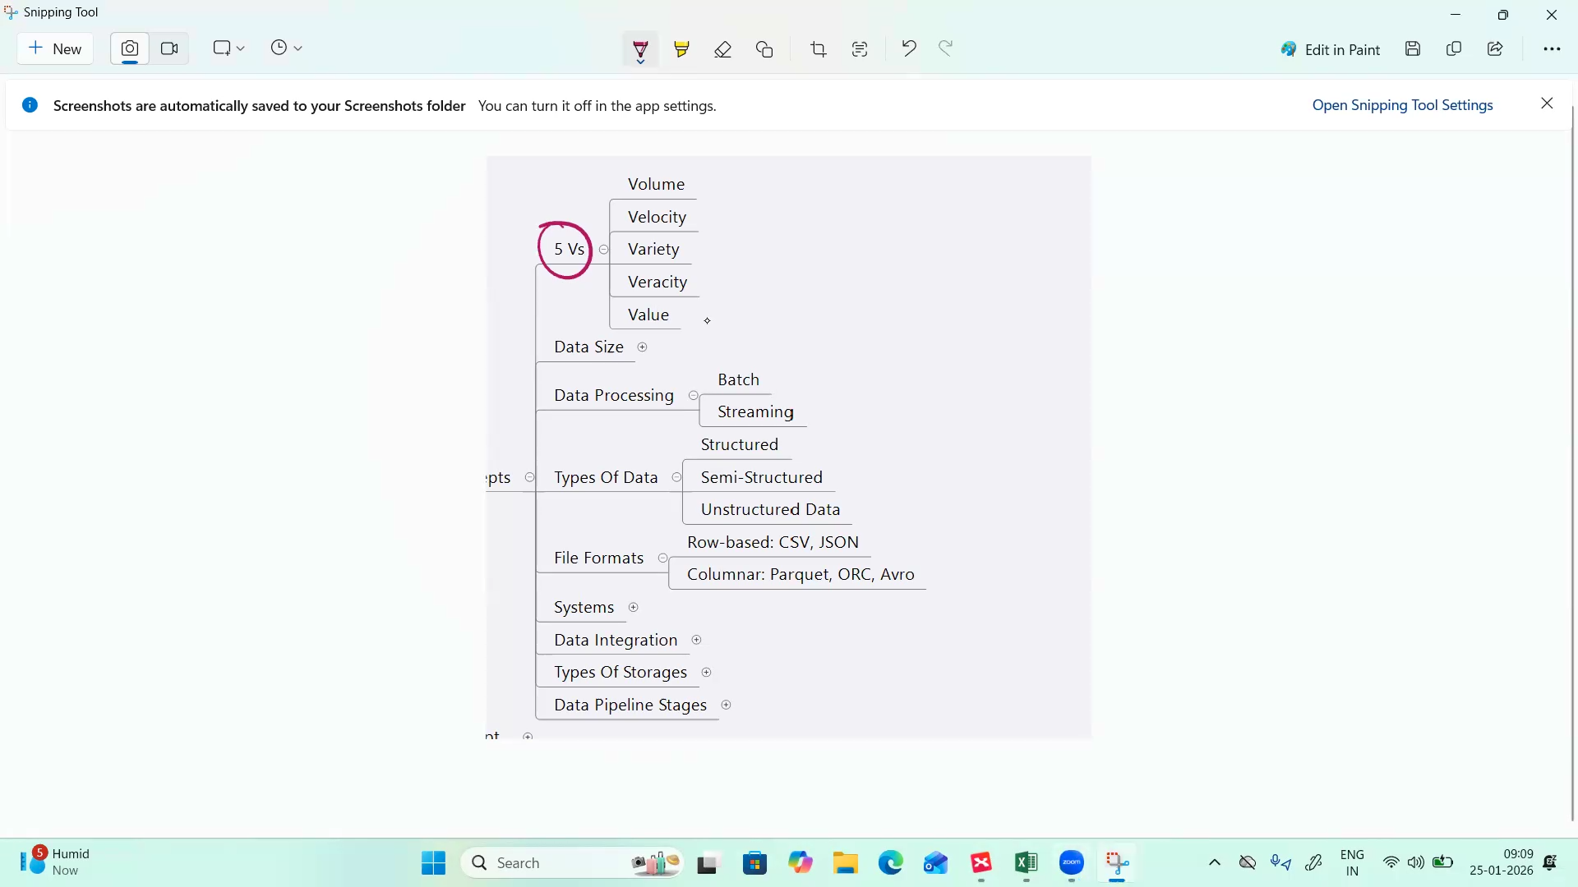
Volume – size
Velocity – data processing
data processing:
batch: source to destination like from source table to dest table
stream processing: using API’s and it is called “near real time data”
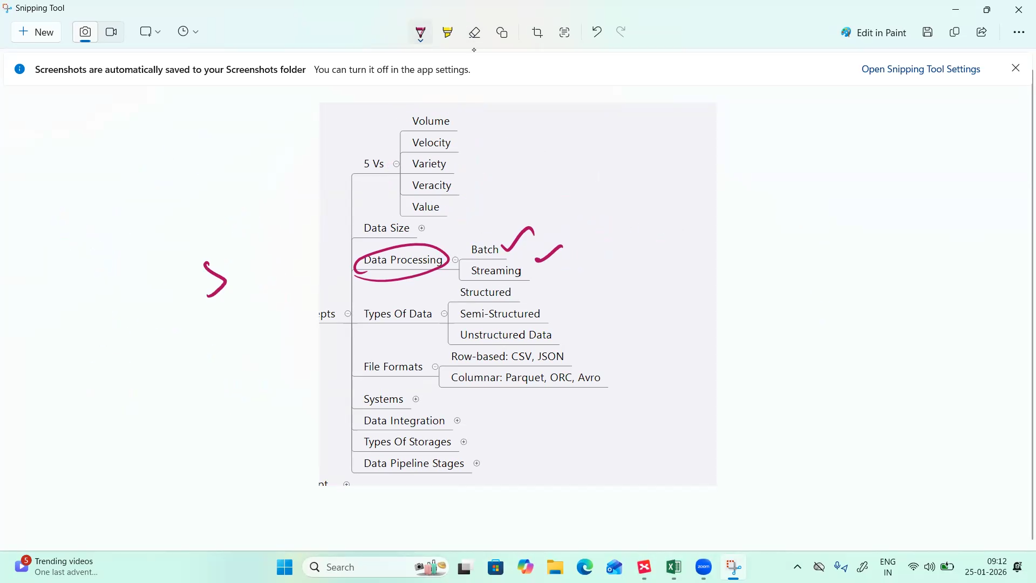
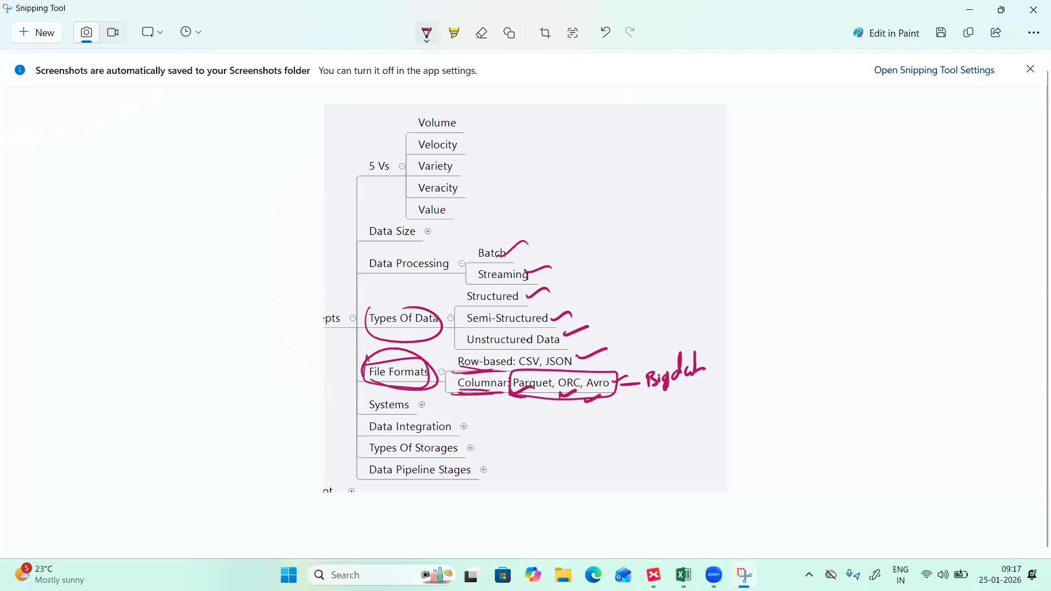
- API input and output is in JSON
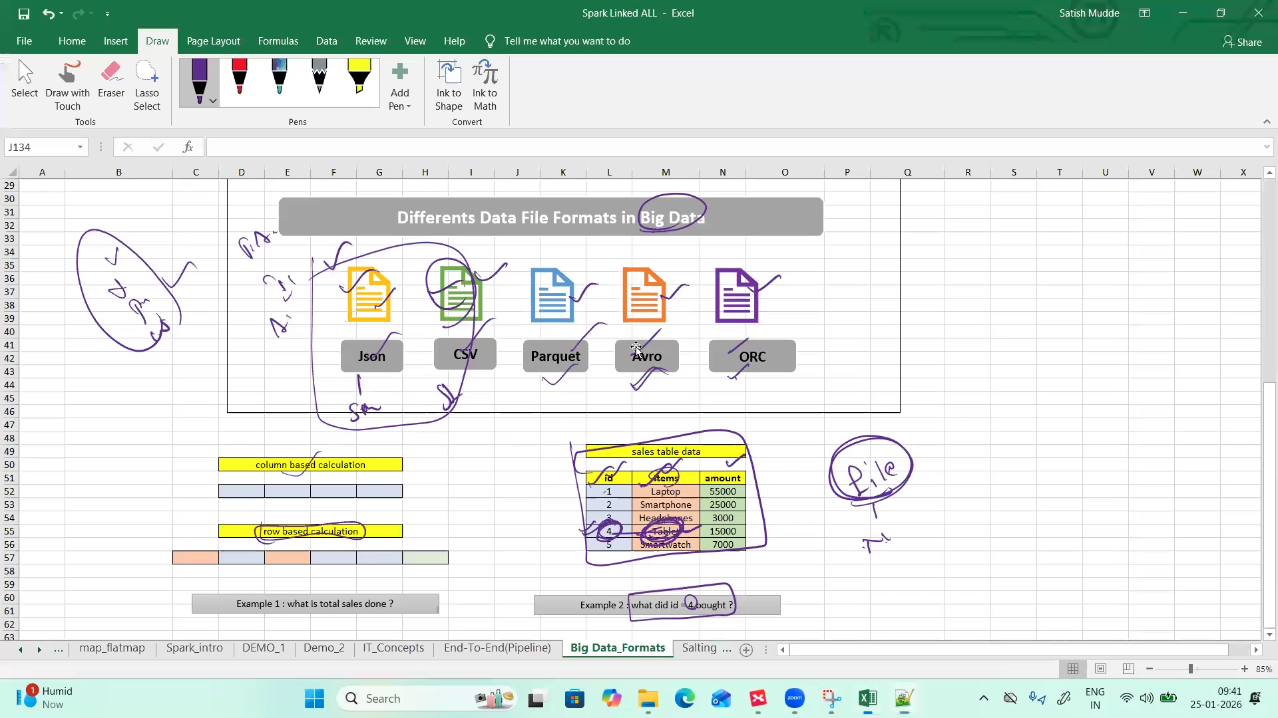
Parquet file format create partition based in the ID
- Like data is placed a small chunk of files based in the ID
- Partition is done at columnar level – structured data type like as CSV

- Avro file format is similar to JSON file format
- It is also Semi-Structured data
- ORC file format is also same as parquet format – columnar level format – structured
Row based formats: JSON,AVRO and CSV files
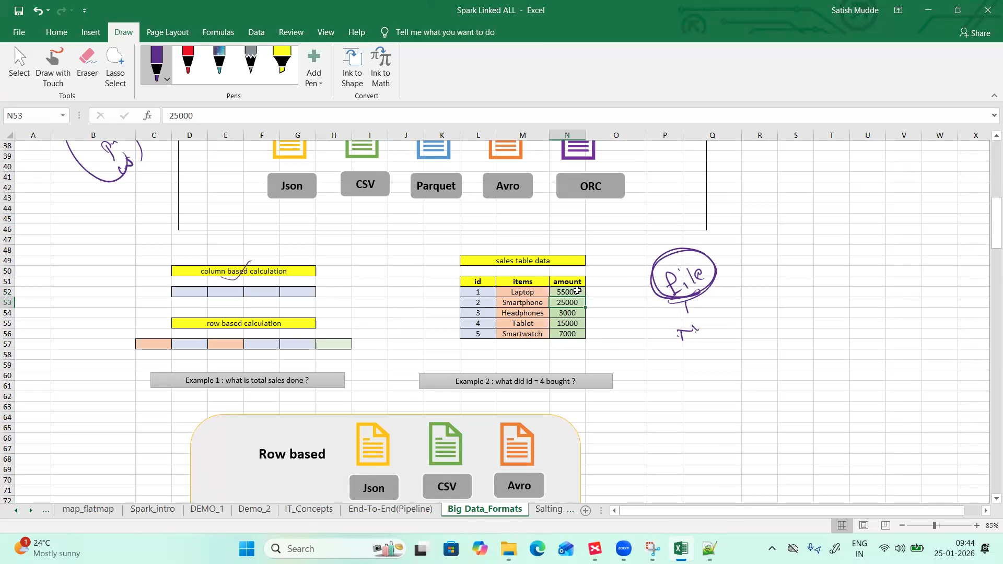
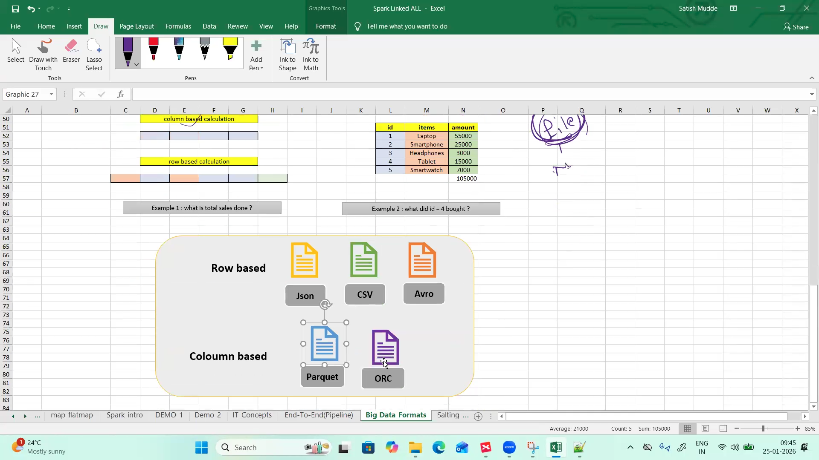
- Performance wise it is best to select columnar based formats like Parquet and ORC

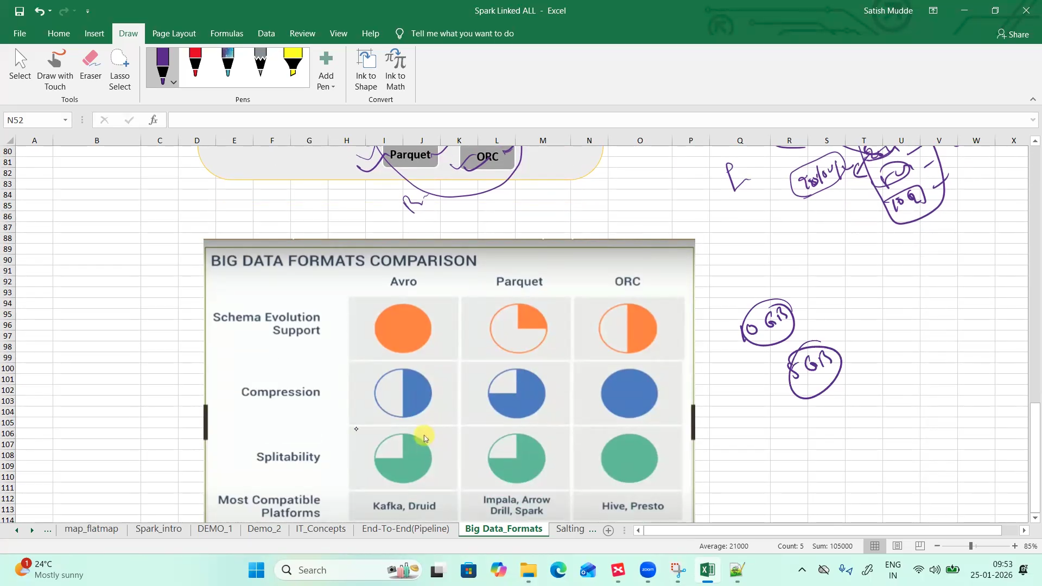

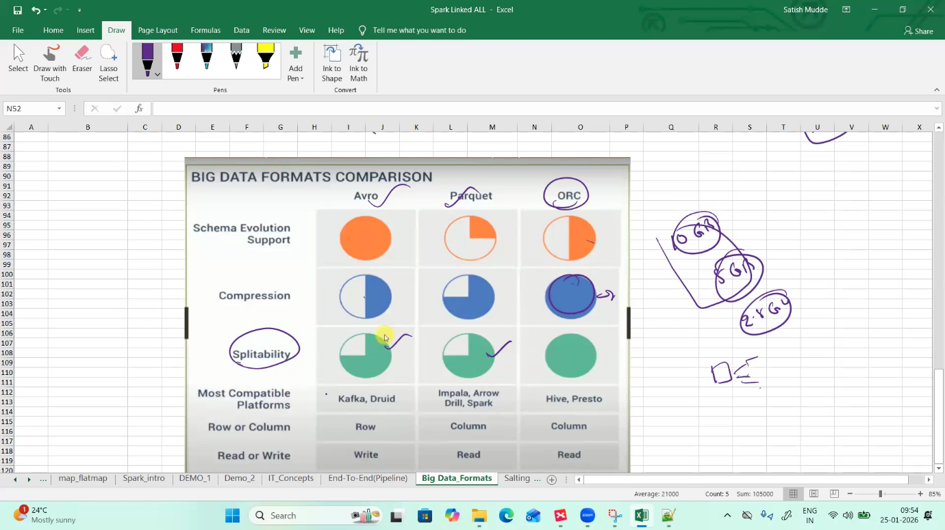

Systems: OLAP and OLTP
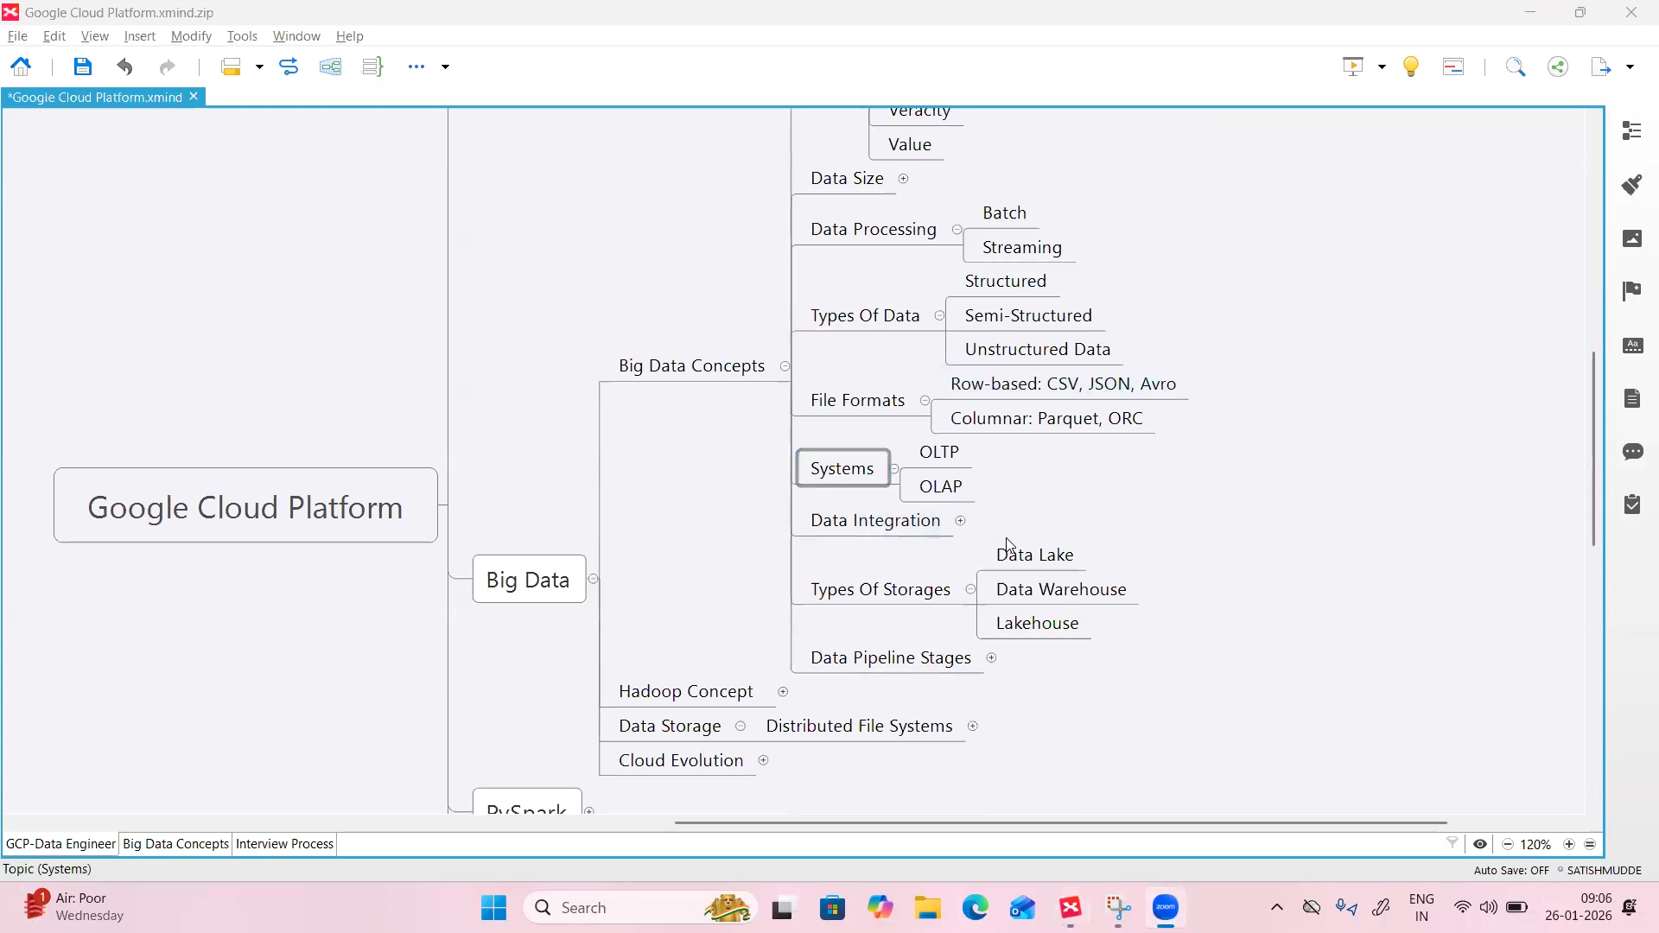

- OLTP data input for data engineer
- OLAP – layer for analysing collected data
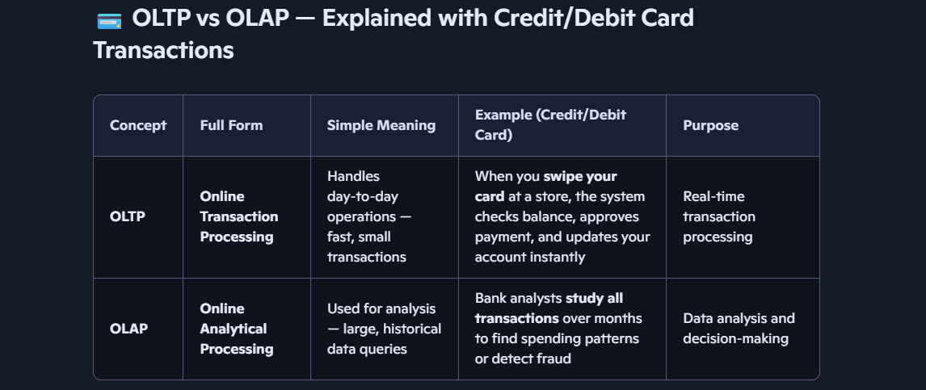

Example in Simple Words :
Imagine you buy a phone using your credit card:
- OLTP system:
  - Checks your card details
  - Verifies available credit
  - Deducts ₹27,000 from your limit
  - Updates your balance immediately
Fast, real-time, small data — like a cashier system.
- OLAP system:
  - Later, the bank uses your transaction data to analyze:
    - How many people bought phones this month
    - Which stores have the most card usage
    - Average spending per customer
Slow, large data, used for reports and insights — like a data warehouse.

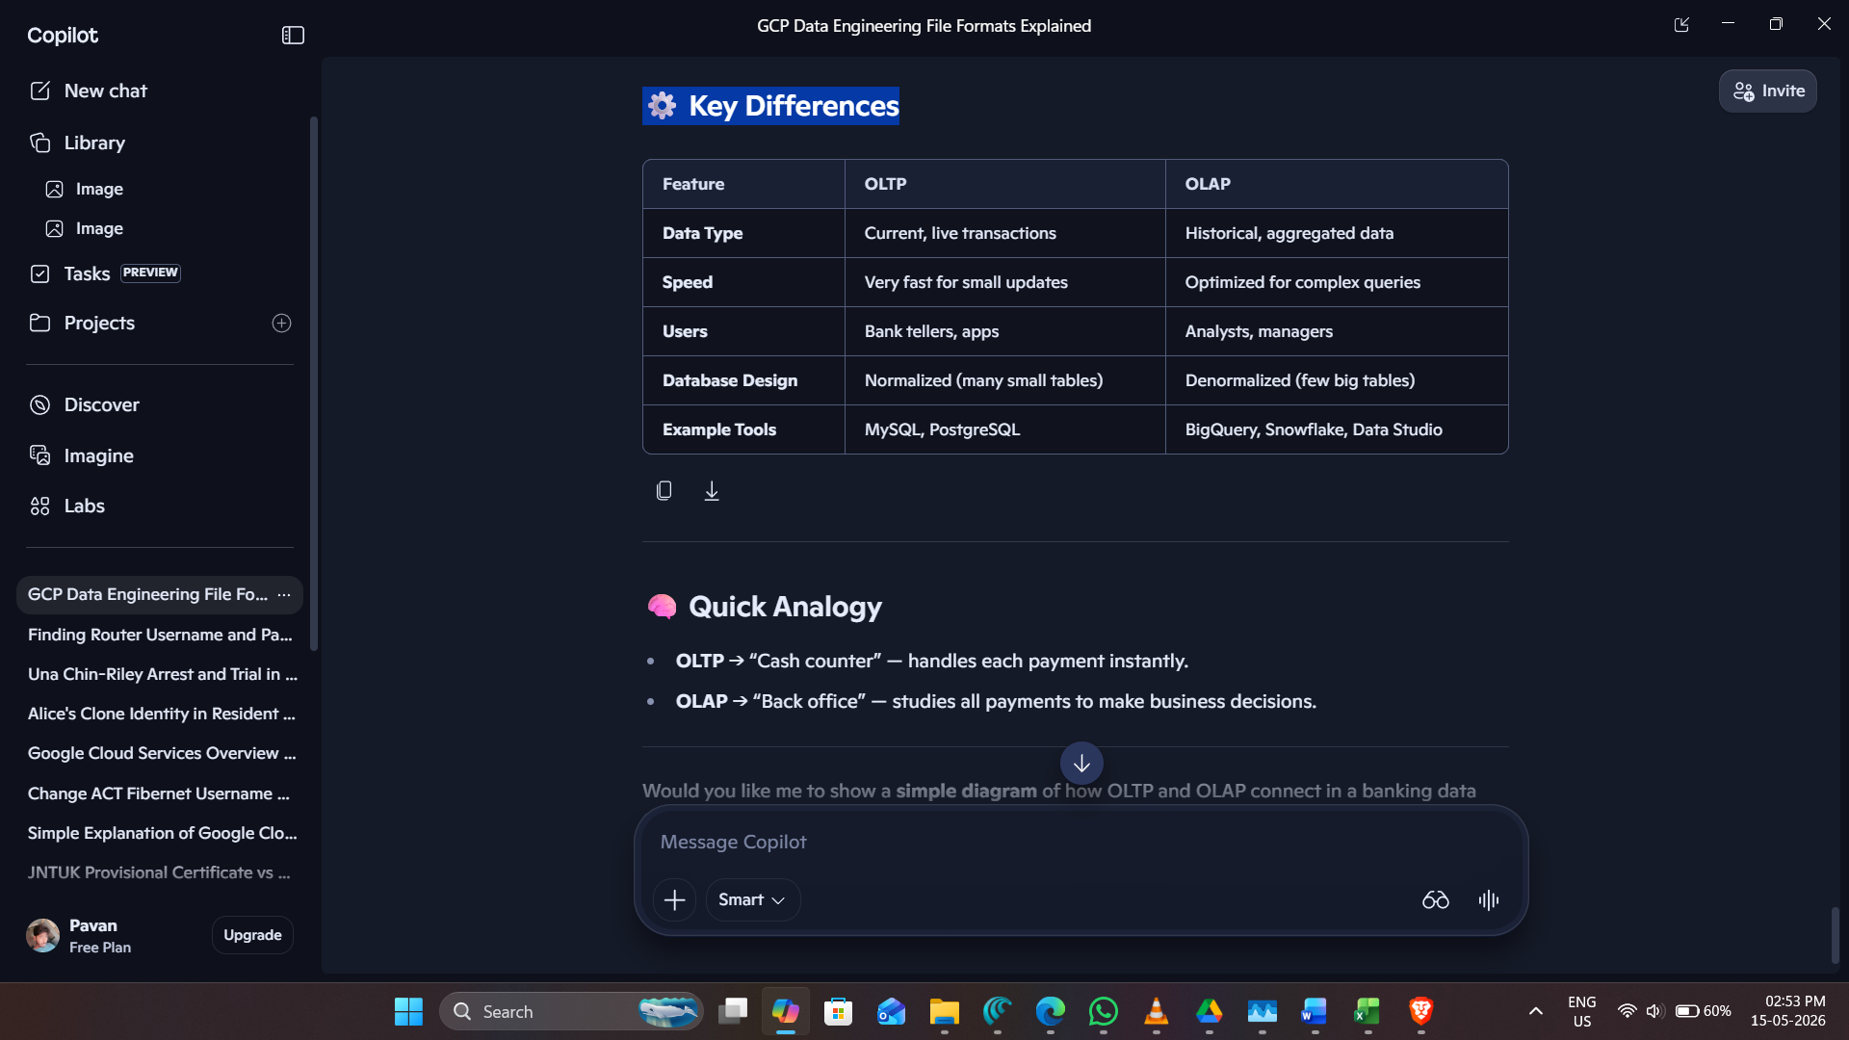

Data Integration: ETL and ELT
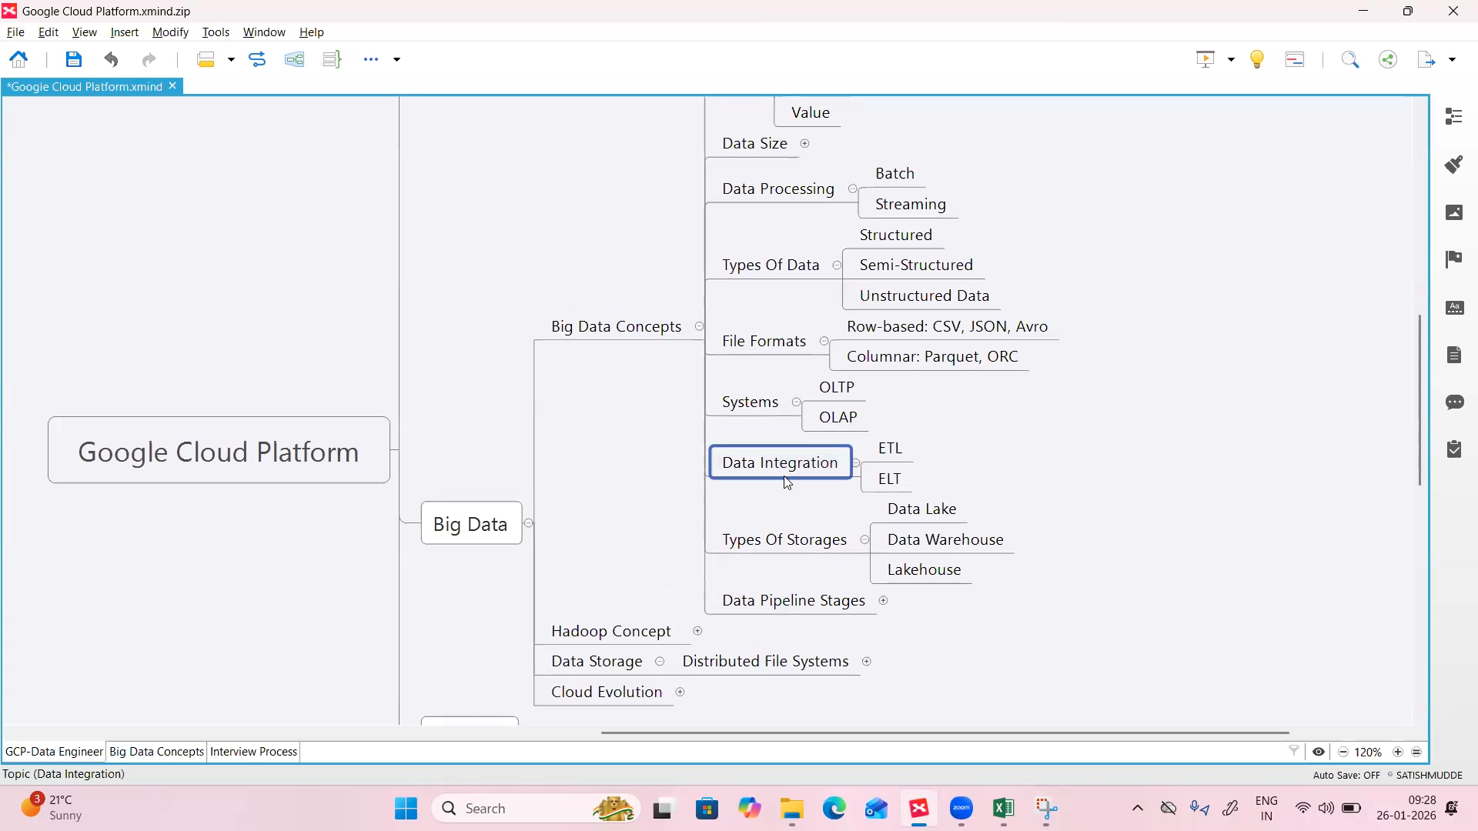
Date engineer has two roles:
- Data Ingestion role
- Data Transformation role

- Data Ingestion role:
… Collecting data from OLTP to target GCP cloud storage system (OLAP)
… collecting data from source and storing in target
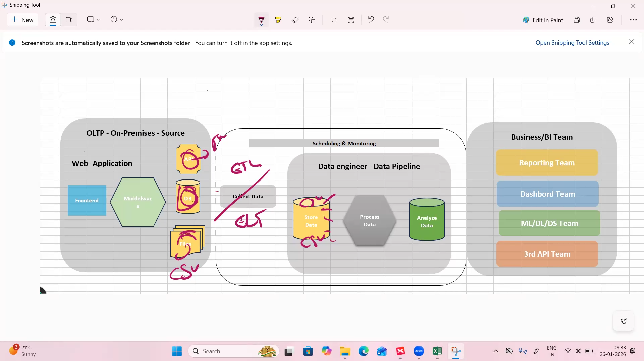
- Data ingestion is done in two types ( ETL and ELT)
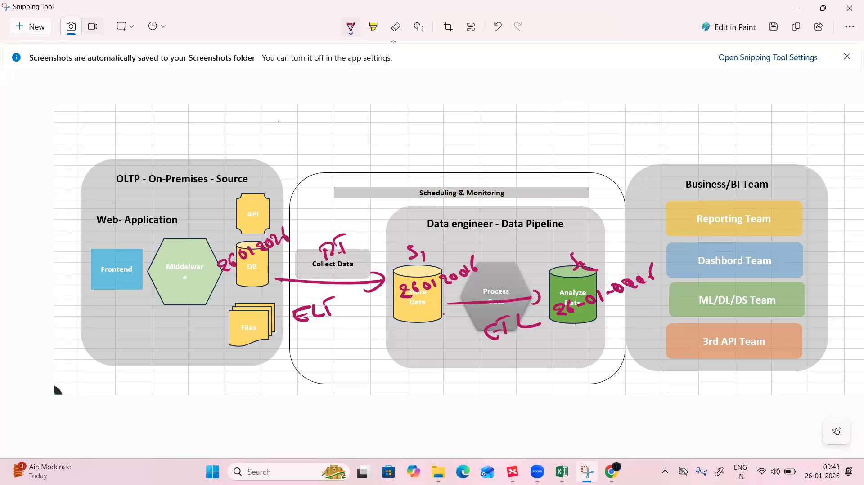
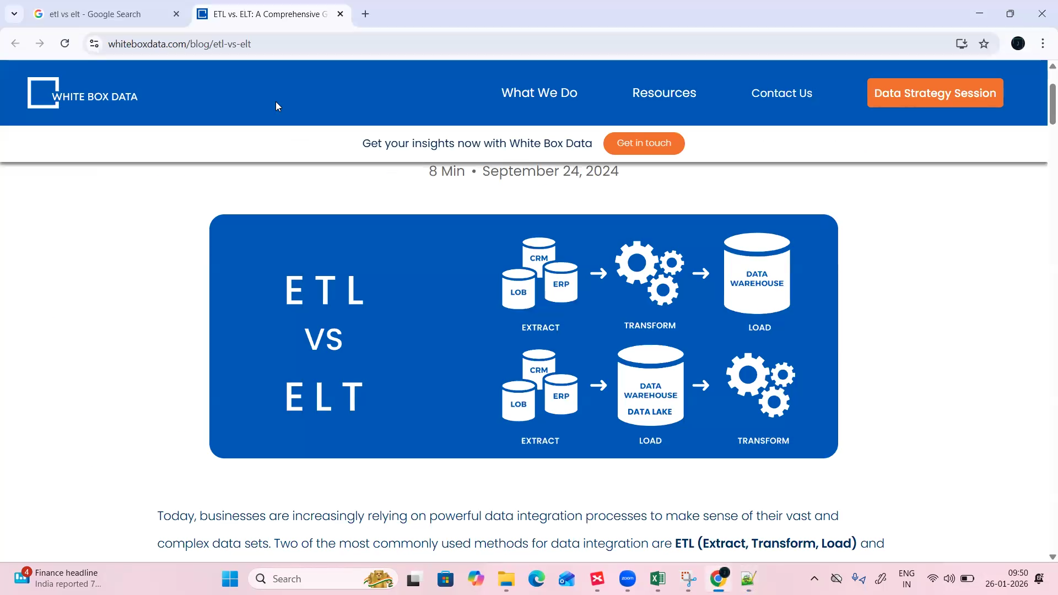

Full load and incremental load:
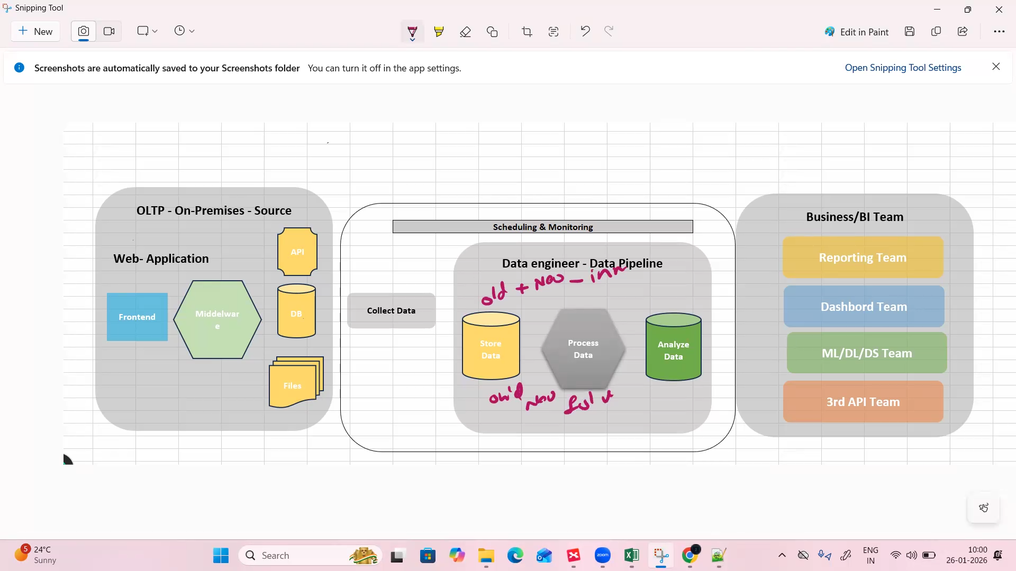
- Old _ new data (new data is appended to old data) – incremental load
- Only new data loaded-overwrite the old data – full load
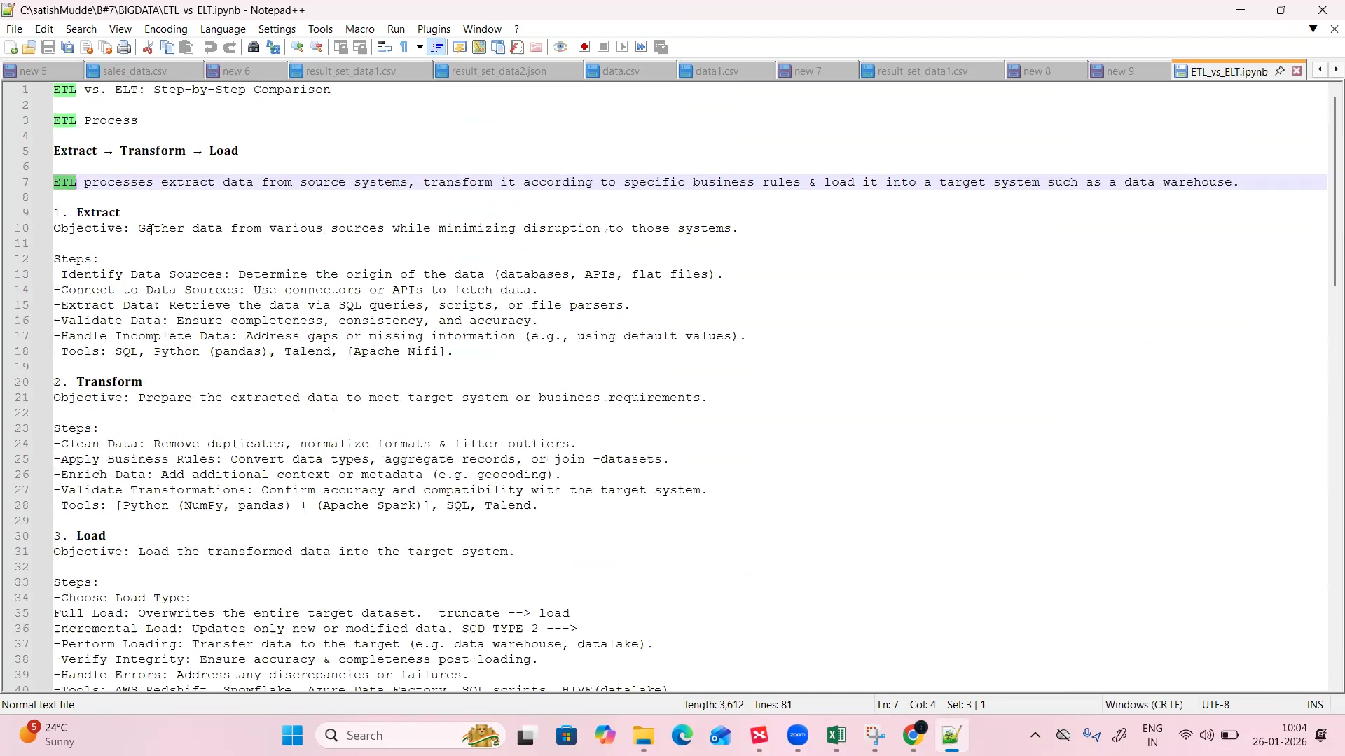

- Here in GCP – BigQuerry + Sql is the ETL
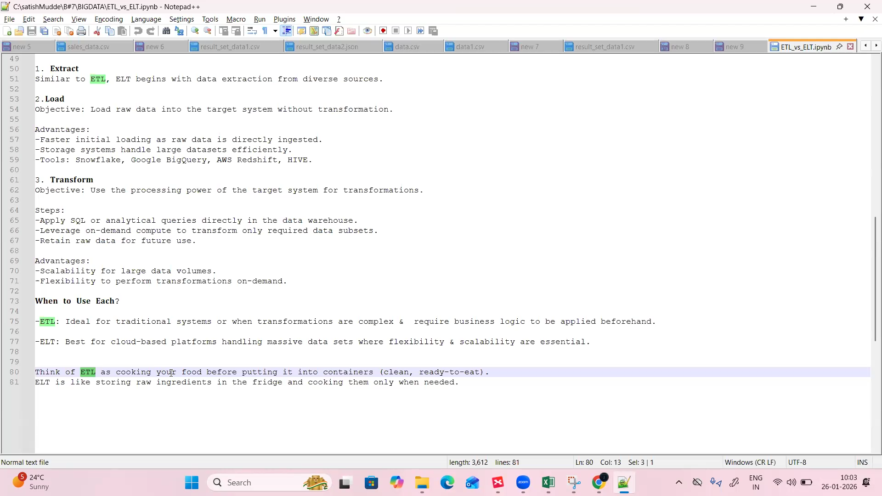

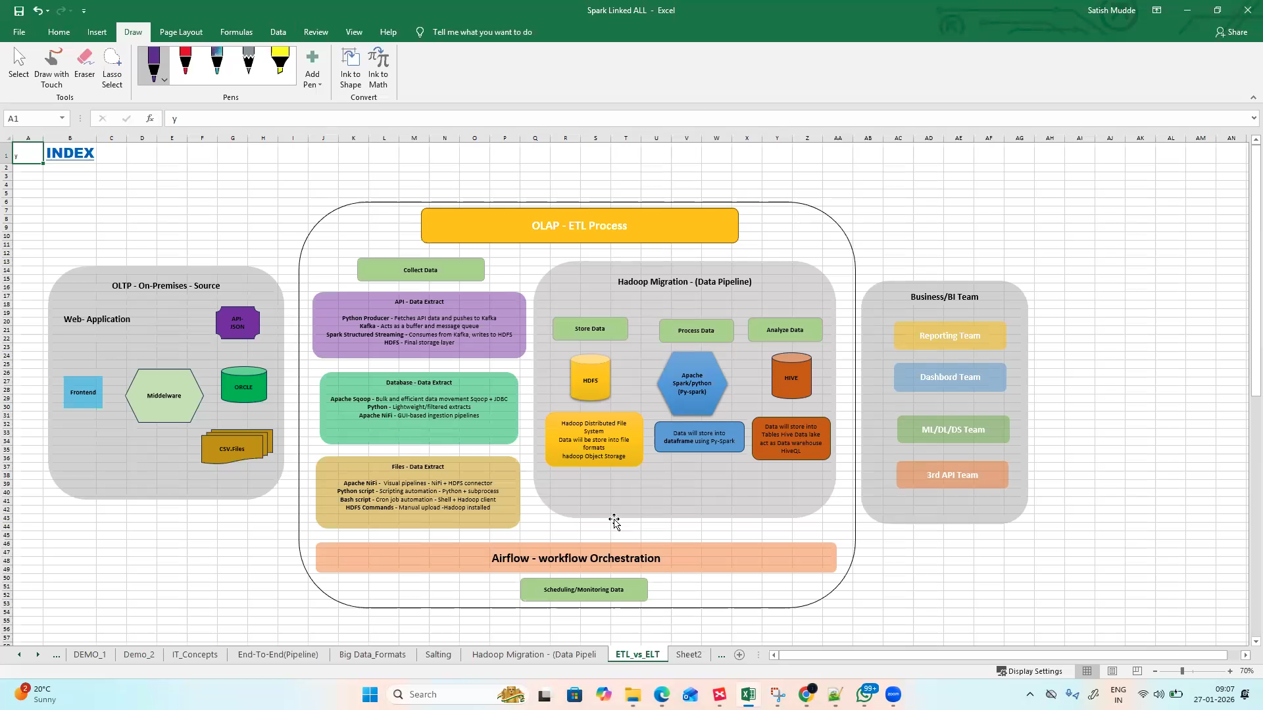

Apache Sqoop is a big data tool used to transfer data between relational databases (like MySQL, Oracle, SQL Server, PostgreSQL) and Hadoop ecosystems (HDFS, Hive, HBase).
Key Points:
- Import: Move data from RDBMS → Hadoop (HDFS/Hive/HBase).
- Export: Move data from Hadoop → RDBMS.
- Efficient: Uses MapReduce under the hood for parallel data transfer.
- Use Case: Ideal when you want to analyze large amounts of structured data stored in traditional databases using Hadoop tools.
Example Scenario:
Imagine you have a sales database in MySQL with millions of records.
- You can use Sqoop import to load that data into HDFS.
- Then run Hive queries or Spark jobs to analyze sales trends.
- Finally, you can Sqoop export the processed results back into MySQL for reporting.
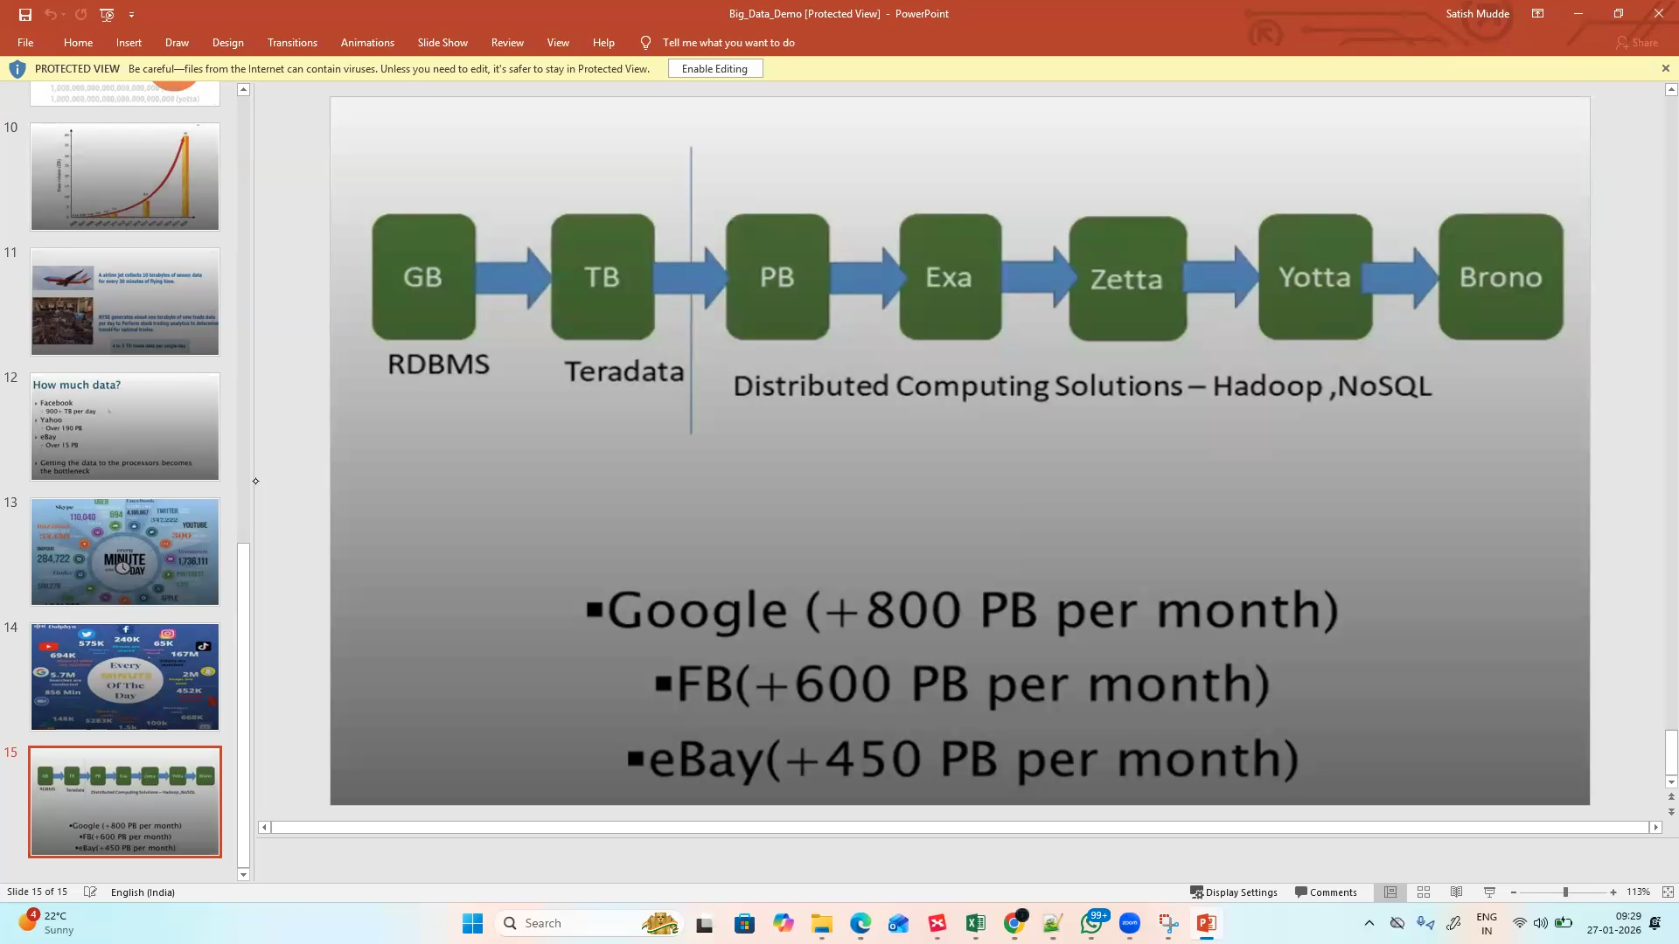
- Hadoop supports no-sql databases for terradata
- Hadoop only have capability to handle petabytes of data , before cloud
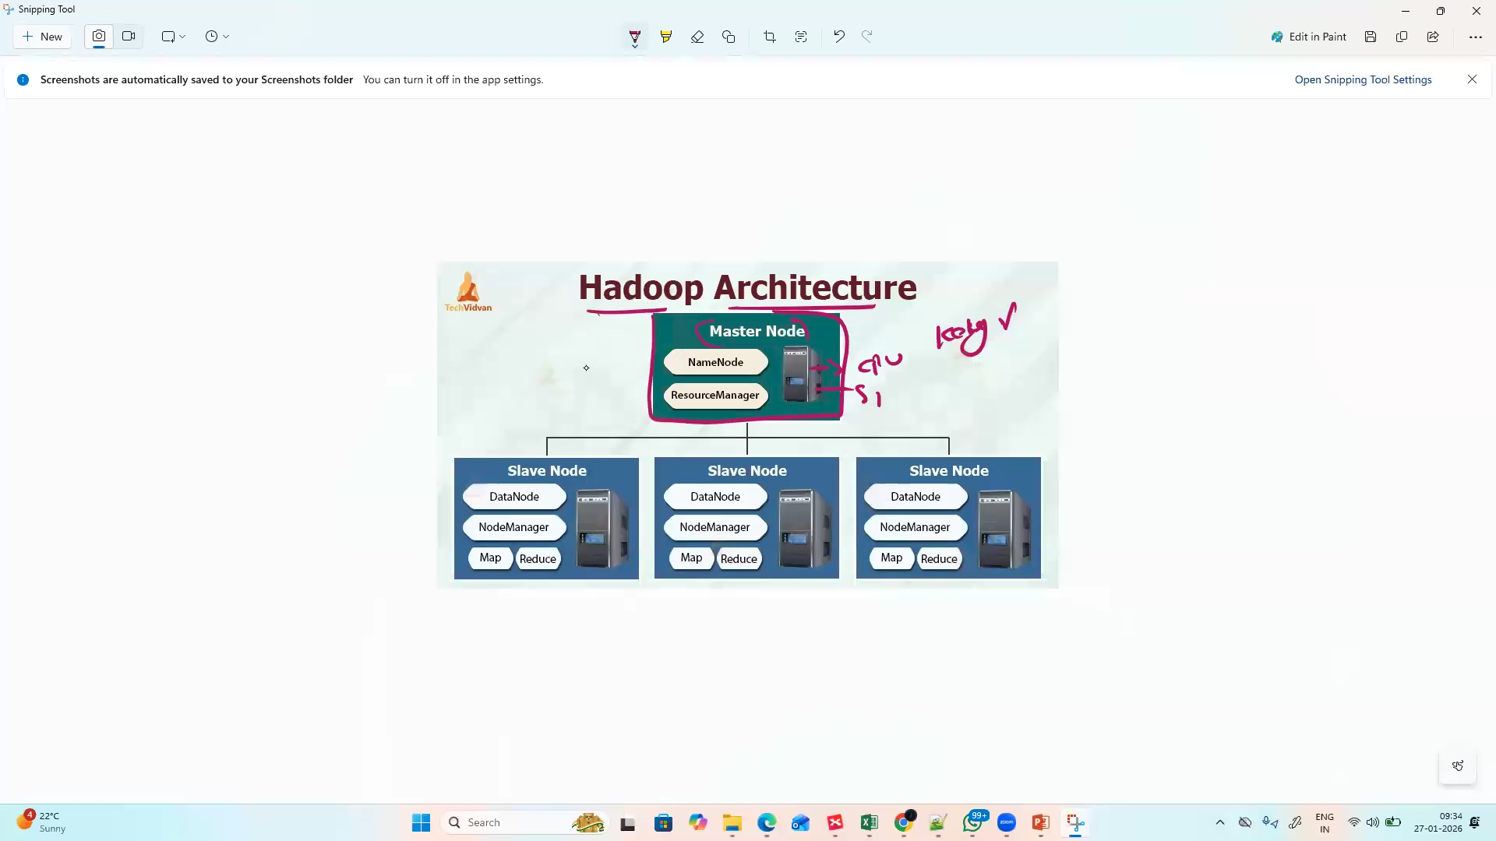
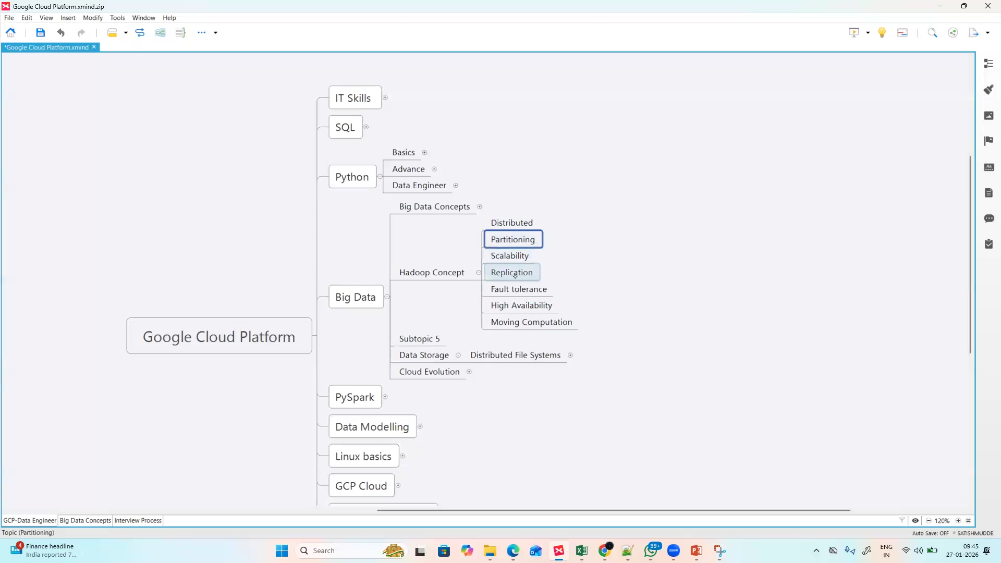
- If slave node is down another slave will be used
- But if master node is down. then there is a node called secondary name node (SNN)
- SNN has 100 % back up node (has both master and slave nodes data)

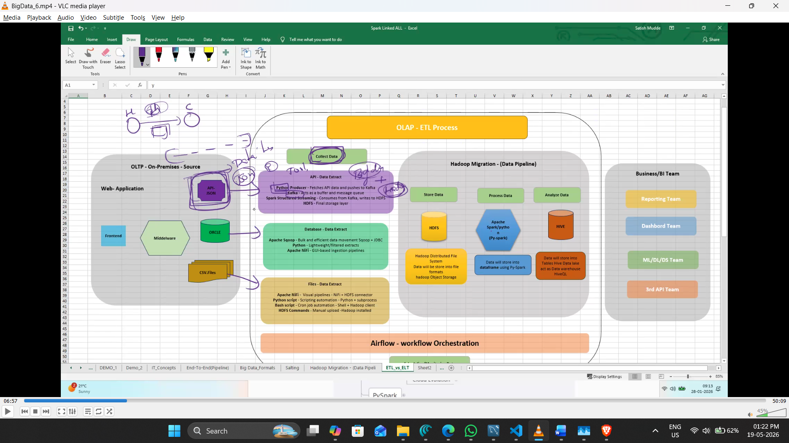
- Kafka tool is used to process streaming data ( related to Apache , same as Hadoop)
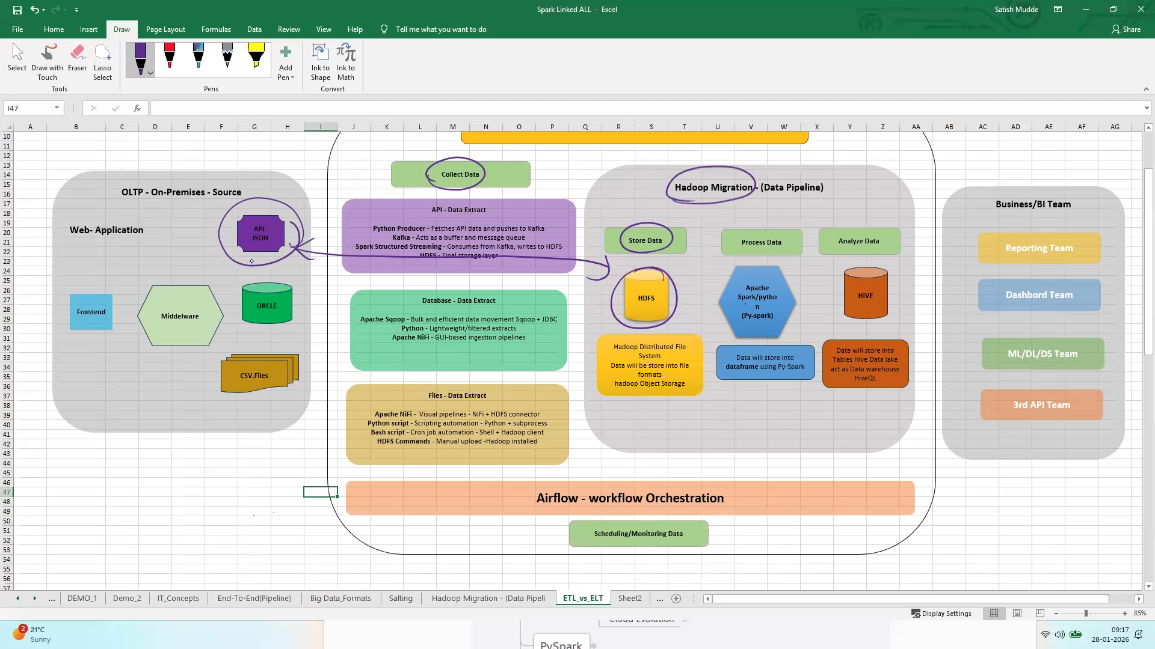
- Apache scoop is used to get data from data source (supports SQL + Hadoop)
- Apache NiFi is a visual pipeline tool
- Transformation of data taken is done based on business rules.

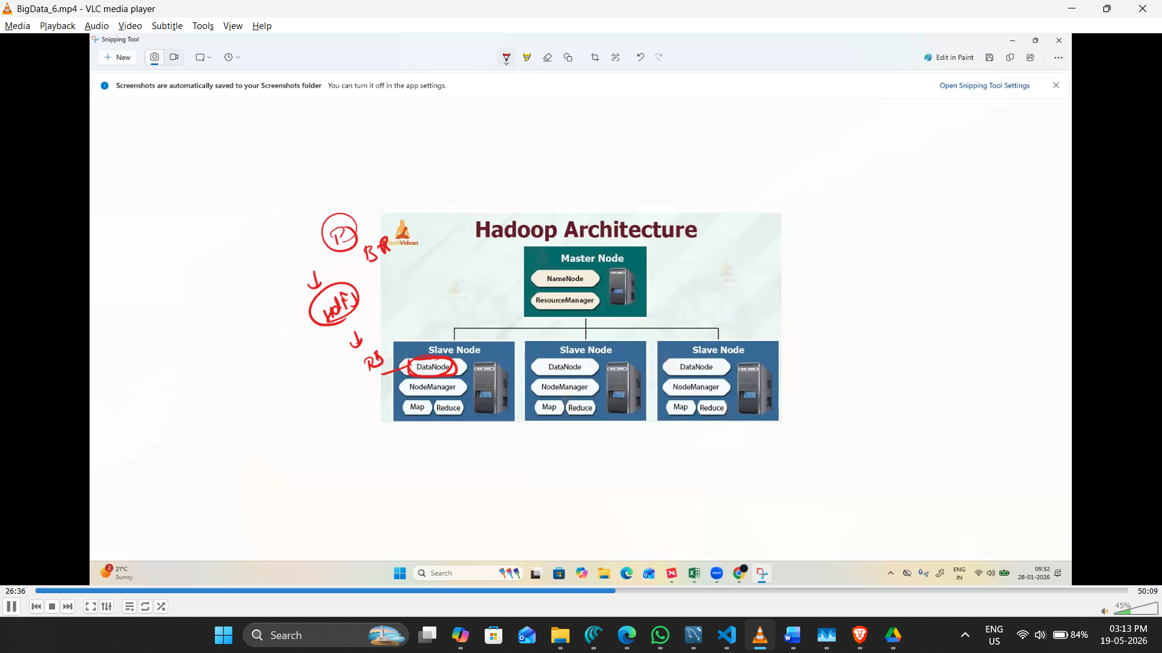
- Data node used to store the data
- To process and filter the data – Hadoop have a feature called Map-Reduce
- Map-Reduce is a coding topic
- Map-Reduce drawback is ... need to put huge effort in development
- Py-spark is a framework and is only used for processing of data
- Hive is the data warehouse ( it is like a database)

Example test project:
- from API we’ll get data
- data is collected using Kafka
- after the data placed in HDFS in Json file format
- after that based in the business rule entire coding is done in py-spark

